**Phase 111**

Most important thing that was affected by ios 14 is reporting or the tracking related reporting and as well as our pixel based audience

So we can make a lead audience



We should not fully depend upon pixel based audience only

Audience testing is very important it should not happen that you ignore the audience testing and doing other testing

So we can test the audience we need to see which different different sources are being developed through which yo cantest your different audience we can start with small budget

Now the second type of audience is

Video View audience or Engagement custom audience

By engagement we mean if you have an instagram account

And then you have facebook page so then you can go to

In custom audicen creation you can also see Instagram account

Where there are people who follow you there are people who engage with your post such type of audience you can create

You can create audience of people who create audiecn of people who like facebook page

SO on the basis of interaction with the page and the like on the page you can make the audience so you need to develop audicne from different sources

You can if you want create Lookalike audience and can do further testing you can show them ad and testing

WE have also option of video view option in custom audience creation

And you will see this option in meta sources mean the sources provided by facebook

IN your source you will see source like you r website ,your app

And the IOS 14 has impacted website and Apps

But other sourcesdoes not create that much problem like the teacher has told about views

When you choose videos option in custom audience creation option then it will ask you what video you want to select

SO based on enagement of the video you want to make your audience choose that audience

Then it will ask you the video you selected on the basis of what intercaction on the video you want to make the audience measn the people who see 25 percent or 50percent videos



Now the third way you can make the audience is by Instant Experience based, Cold audiences

If you have used instant experience in your ad then it will work

Cool audicen is not affecting

ON 19th January Year unknown facebook removed many cold audience

There were many audiecnes which were relted to Religion ,Finance . make money online these type of audience which isnot right and through them different types of ad can be created they can be targeted differently so facebook has removed them (I don’t know)

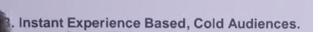

If you are learning Facebok ad or Google ad then in todays time we cannot think that what we have learnt will be applicable for next 5 years

Whateer you may have tought today that option could be removed tomorrow

SO if you want ot do it then it is important that you go deep in it

It is important that you follow there updates regularly

Try to develop different ty[e of audience

First try that there audience should be formed measn our indtgram follower should be increased our facebook like should be increased

The video we put should have engagement

Then you can create further audience on the basis of it

**Lesson 84:-**

In this lesson we will learn about **What to do after IOS 14 Update**

We will talk about after IOS 14 what are the setting which we need ot focus on

And by what we need to configure recommended setting so that IOS 14 update impact would not be on our ad account

The damage IOS 14 has created to those website that is our Ecommerce based website because there events are very important and there is no only one event there like we have a normal website there you work gets done by only one event suppose if there is thank you page then we say we have generated lead and in the name of lead generation we make an event

And whenever a user visit thank you page then event happens but when we talk about ecommerce website then we have multiple ecommerce based website like our view content or add to cart , initiate checkout , purchase as we know after IOS 14 the efficiency of pixel has become weaken and the pixel was the thing which track that how much viewcontent is there

And how much initiate checkout is there and then show there information in event manager because pixel is not able to track properly then events information is not accurate there or when we run our ad or do event based optimization then that I not possible These problem was created after the emergence of IOS 14 but there must be some solution

So what we need to do to keep us safe from them as a marketer then what we need to do and what does facebook recommend

Facebook in its documentation has already mentioned it that you sould have domain verification

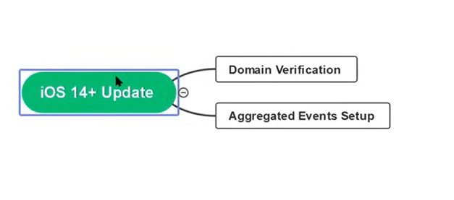

Put it in your checklist that whenever you make a business manager then you know the business manger you are making then you know the website you are going to promote it inside it so do the domain verification in starting

And second point is that after setting up your event you do aggregated event setup

SO for the purpose of domain verification go to your business manager setting

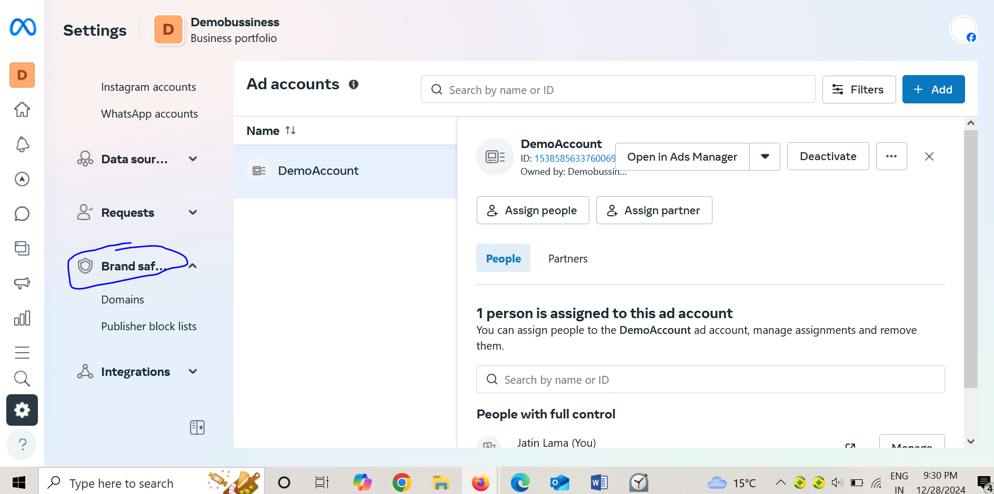

And then you can choose the Brand awareness as marked above

And in inside Brand safety you will have option of domains

Since teacher have not added any domains it is not showing something and showing as shown below

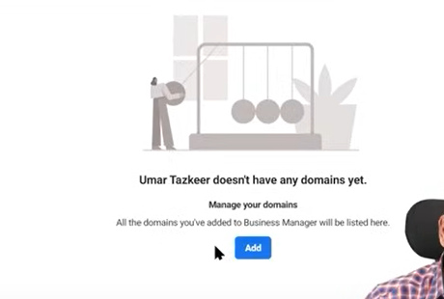

But if you have multiple domain then there will be a list of domain there in place of add button

What we need to do is click on the add button

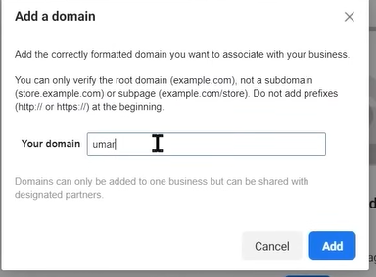

Now add a domain window appear type your domain in the your domain field and then click on Add button

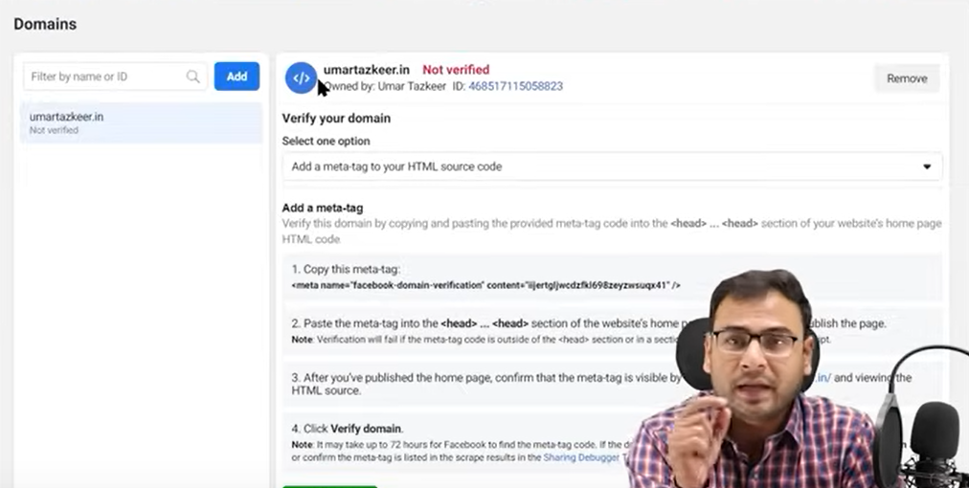

Now it will tell us methods of how to add domains to our business manager

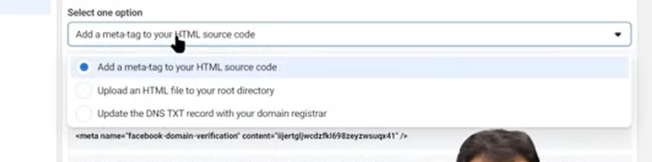

Now you can see as above many ways to add it as shown above

IN google console when we verify our website then there it give a code which we have to put I t in our Head section

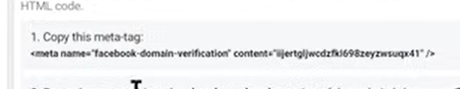

Copy the code as shown above

After this click on verify Domain button

Second option is it give is to download the html file and then upload it in your root directory similarly in the way you upload robot,txt or sitemap.xml (I don’t know)

Third option(I don’t know)

Is that update the DNS txt record in your domain registrar

Meta tag option is more easy as compared to others

This is the step 1 you can use to avoid ad account

**Phase 112**

Don’t think that you will avoid it 100 percent then you are mistaken but tbecause of this gudelines you will be protected to an extent

Now woll do step 2 that is aggregavated setup

You just have to go to your event manager

And you must have many events there

You just have to do these thing from starting measn when you will setup the pixel in your website and after adding it and then to track many events you will make many events

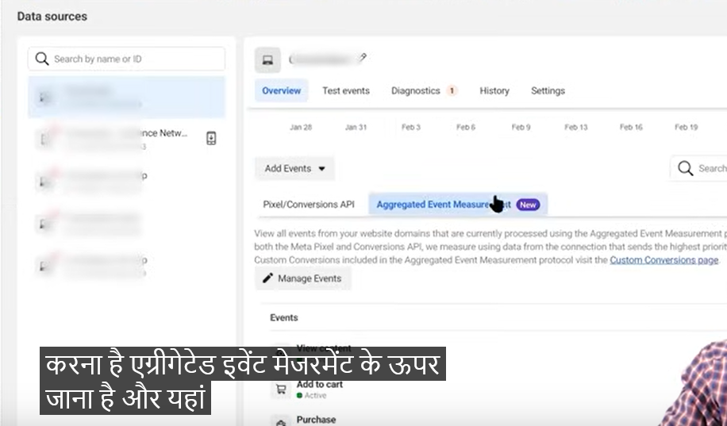

SO in event manager go to Aggregated Event Measurement tab and you can see new is written aver there means new thing

Now click on Manage event

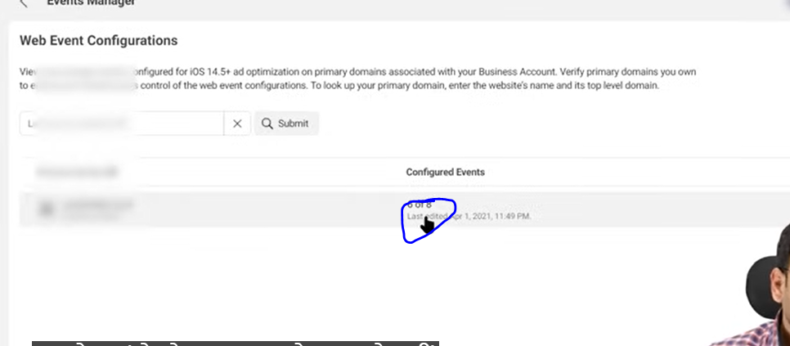

Now click on the marked area above(maybe related to an aggregated event) and then a submenu appears as shown below

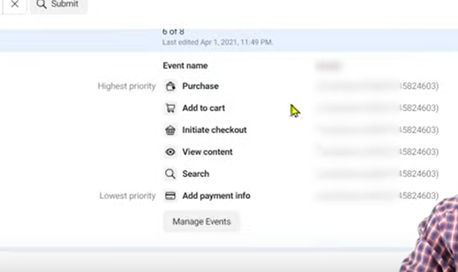

Now click on Manager Events

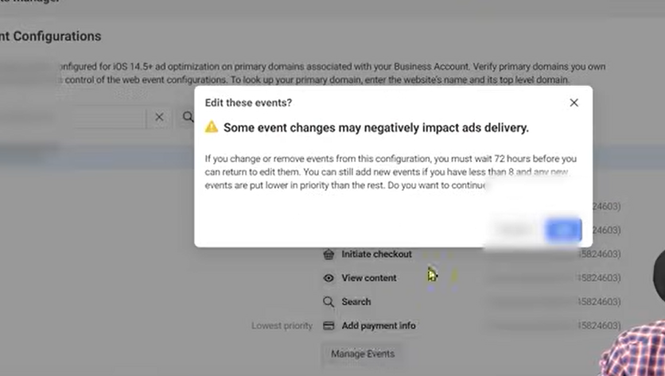

Now a prompt will appear .click on edit button

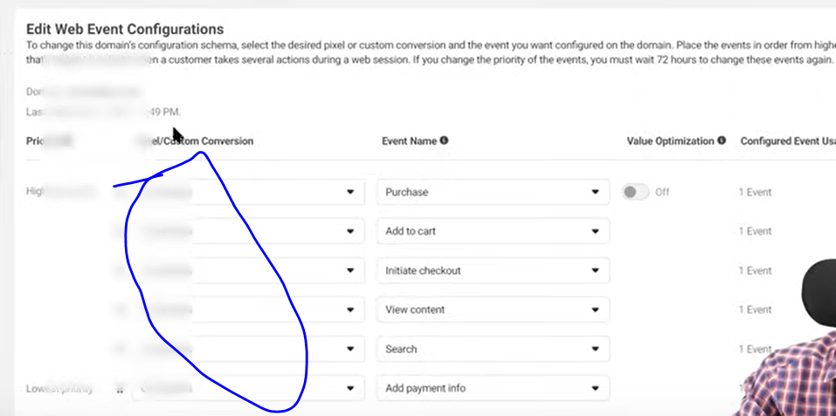Now you will see a screen like above Now you just sleect the pixel as marked above

And then select the event s in the event name

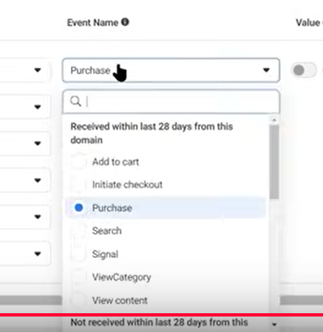

When you click on the then you will see the option above

Always make sure your events are ordered according to from highest priority to lower priority

Purchase is usually the high priority

If you think that a particular event priority should be different then you can just drag and drop

You just get the option of 8 event maximum do here you can setup 8 events here

NOw click on apply button

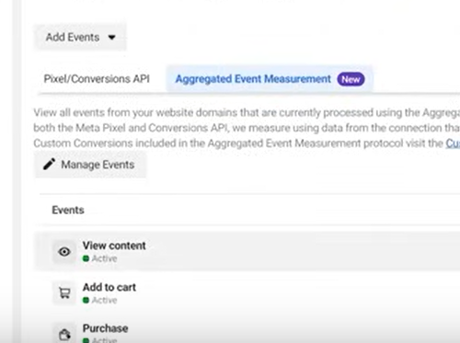

Now you can see your event as shown above

And for that you need to configure your events as shown above

You can see below only 6 out of 8 is configured we can want we can configure the rest



**Lesson 85:-**

In this lesson we will learn about **Setup A/B Testing in Facebook Ads**

This topic is confusing because when we setup A/B testing then we get many options

There are generally three ways by which we can setup AB testing

Or If we want to setup AB testing then we get three different navigation

Teacher recommend us one way which is very smooth and you will understand it easily especially beginners but that doe not mean that other way is waste

Whatever the way they are of setting AB testing is almost same

It is not like that following one will decrease the performance or your campaign will be setup wrongly

So we can understand easily so teacher is telling only one navigation to reach it that is easy way

First way is that you must have seen the experiment section In facebook because if you do AB testing and the result yo get you will see it in experiment section

Teacher will not recommend us because navigation is complex

Second option is that whenever you set up new campaign in the ccampaign level setting you will be given option

If yes then select it

When you create the campaign and when you publish it then it will give you a window and then ther you will create different version there so that you can do testing

It may be slightly confusing the confusion is that when the campaign is created then you have option that you can select your variant there is slight confusion there

The third option is that you have already created a campaign and there is an adset there

And in this one adset the age group of 18 to 24 audience exists

And the you will have a confusion whether we go with this audience or with with different ad set of same audience but with different ad group and the age group is 24 to 35

Whether we go with former or latter we will say that in the ad set we will not touch anything but we just need ot bring change in some audience and it is of age or if we want to text on the basis of gender then we change the gender here and in that particular case the thors way of setting AB testing is useful

SO in this ad set if we have one adset then we create a version 2 of this ad

So suppose we have three variation of adset all three of the have same configuration but have difference of different age group

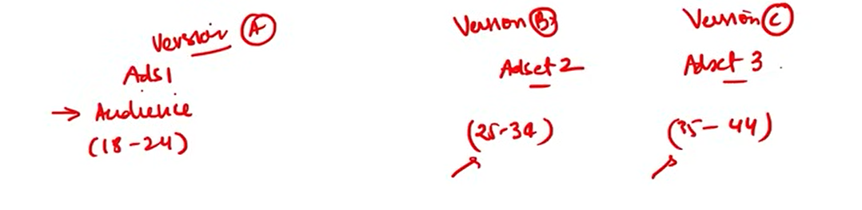

And now the facebook system will judge among them which ad set will perform better

When we say which ad set is performing better then we judge it according to a parameter to it. We will not judge it without thinking we will judge it on the basis of parameter

Suppose we say Ads 1 is winning bit on the basis of what parameter

We can say it can be cot per result basis or we can say impression basis or we can say on the basis of number of leads on what basis

So there are two things which we need to take care of that is

What we are going tp test as the teacher have already told us we are testing

And the second thing is on what basis we are going to test it which thing we will mark and on that basis we define that what adset is winning

Lets say It is cost convergence

The adset whose cost per convergence is low then it is winning and other than that we have to decide some timeframes lets say we want that tis test should run for 5 days and hten we take some decision

So you can unserstand its fundamental

SO we can summarise it as shown below

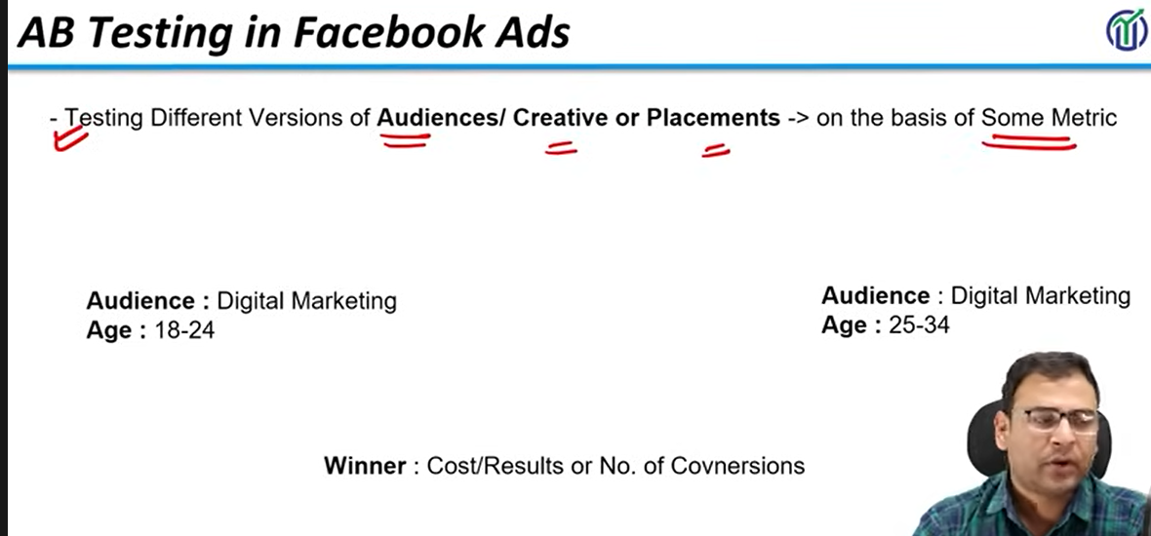

**Phase 113**

Now we will see it practically in our facebook ad system

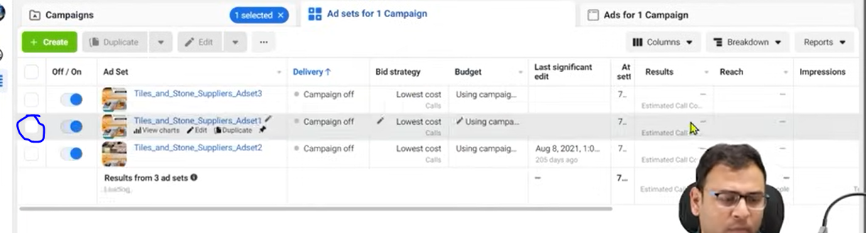

Suppose teacher has three ad set

And he is confused for adset1 in middle of the list

Click on the marked one as shown above to select that ad set as marked below

Teacher is recommending this way to do AB testing

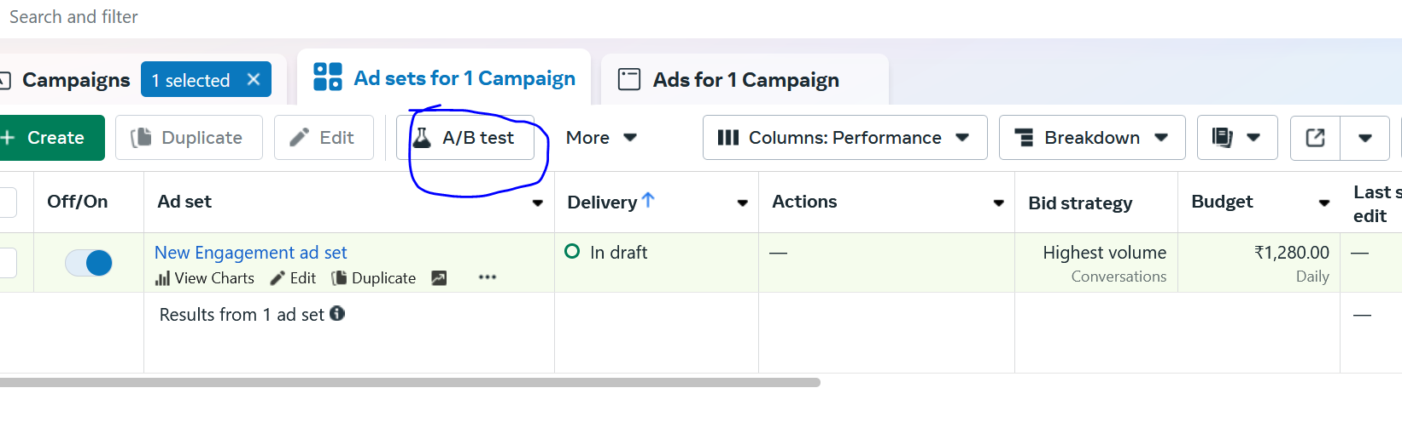

We will see from teacher perspective

(In my case when adset is not selected then it shows the option of A/B Test similar to marked above but we will follow the teacher I think we need to configuration for it in future which I will see but for now we will follow the teacher.)

Now a new window will be opened

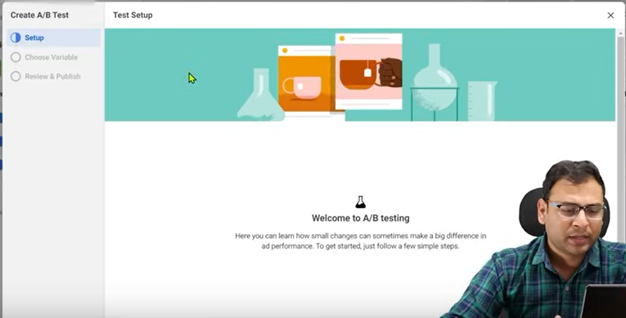

Now click on get started button present in the window

NOw the below window will be chosen

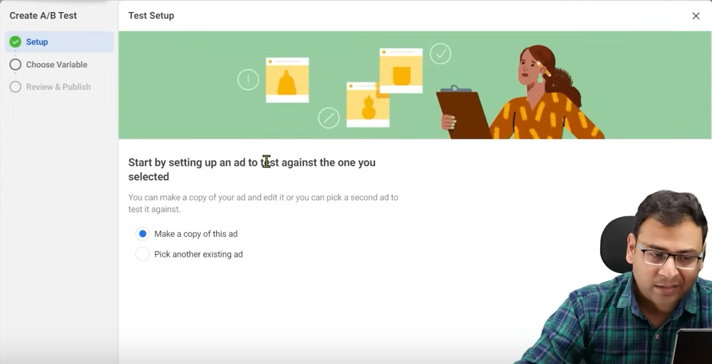

We select the make a copy of this ad radio button

Because we want to use the copy of the selected ad and then we change it and test ti

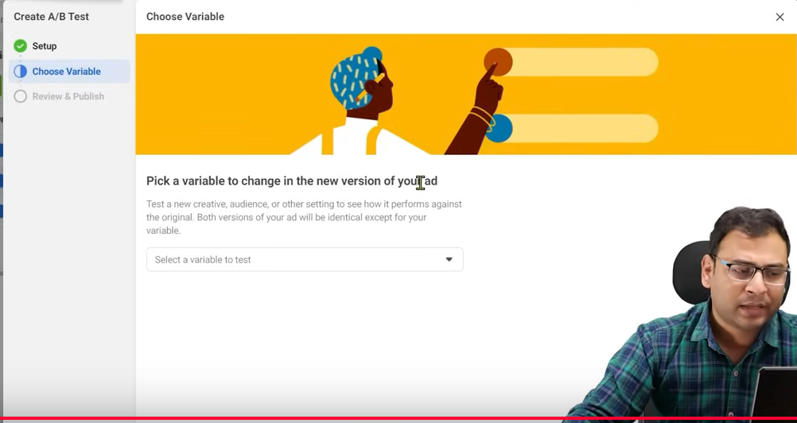NOw it will ask a variable to change in the new version of your ad

So now click on the select a variable to test field and then a submenu will be opened like below

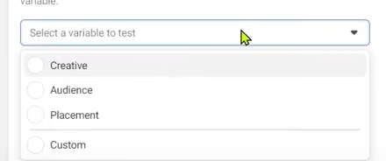

Now we select the audience

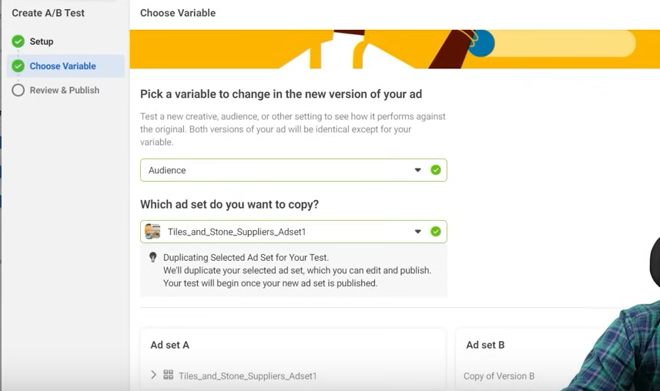

Now in the text field your ad set you selected preciously will be shown whose duplicat will chosen

As you can read below the adset that your test wil begin once your new ad set is published

Now you can see ad set A which is original and the ad set b version of your ad test (who knows)

Now click on next button

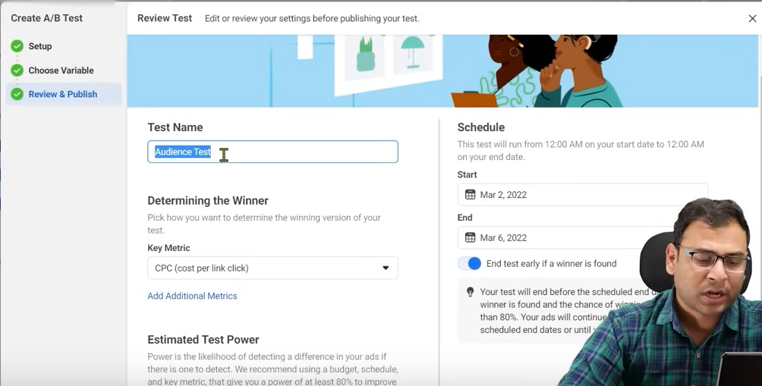

Now it will ask you Test name and you enter it

You can name it on what basis you are creating new version

Now click on the determining the winner field and then a submenu will be opened

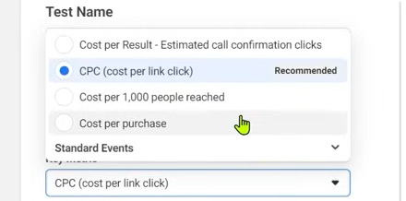

Means what you will consider your campaign win

NOw suppose we choose Cost per result

Of this was lead generation then it would have been Lead per result

If it was call tehn it wuld have been call per result

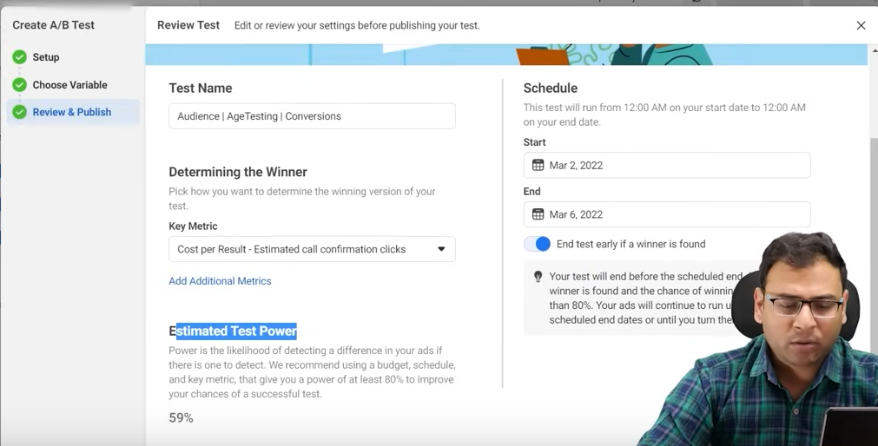

Now estimated test power is 59 percent (who knows)

We will also set schedule

Now click on duplicate ad set

NOw our just ad set is duplicated

It is not like that your AB Test is live

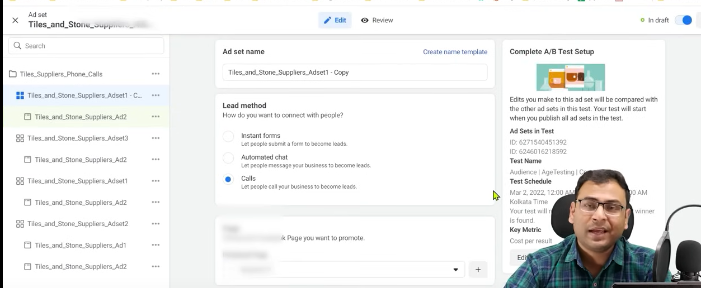

Now in right side you cansee the complete AB Testing

In ad set in test you can see adset id’s who are in testing

And test schedule tell us the schedule

And now on the baiss of key metric we will get our result

NOw since its copies is made we go edit ti

After editing the ad duplicate version we will publish it

Once we publish it then our test will start running

Now in campaign list

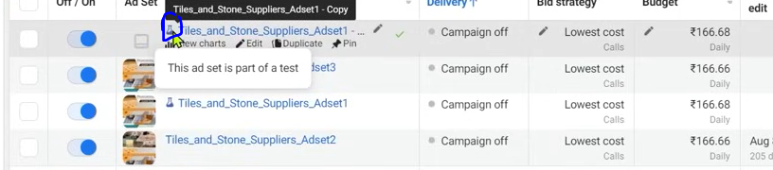

You see the marked area on the list above is that adset is a version for testing

In both ad set for testing the budget is almost same

If you don’t keep it all the same then for testing you choose different version

Means you give power to other variable also (who knows)(maybe becaue many is involved while targeting someone using differentvariables)

Where you will see its result

You will see It by going to left menu

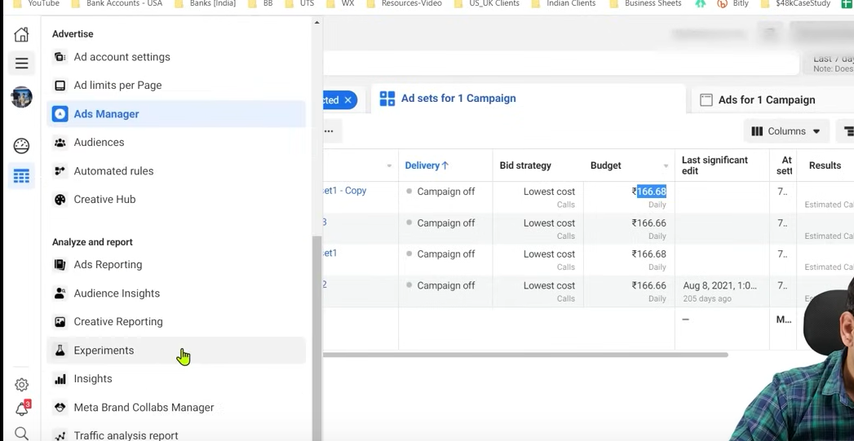

And then go to Experiments in Analyze and report button

Here you see in detail the result

AS Teacher has said you can do ab testing from threr also

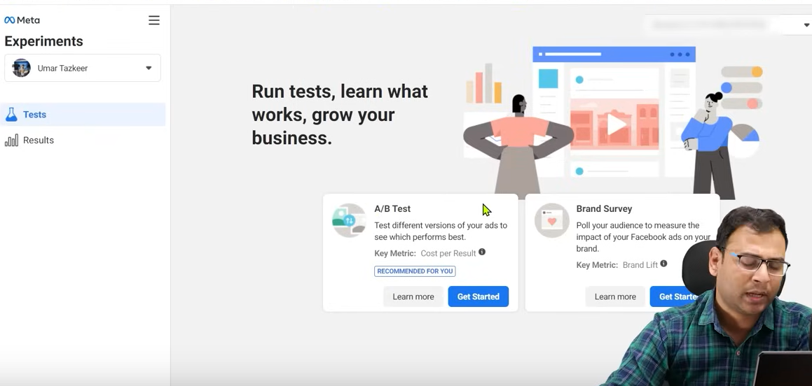

As shown above in test Tab but that will be very confusing

Now we go to results tab

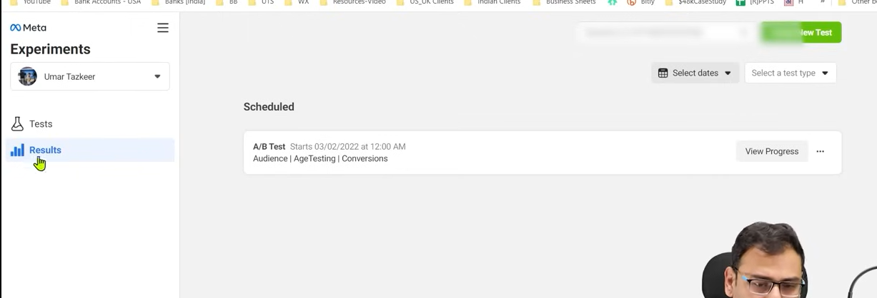

And now in the scheduled list the list will be shown which has scheduled for testing we click on your progress button

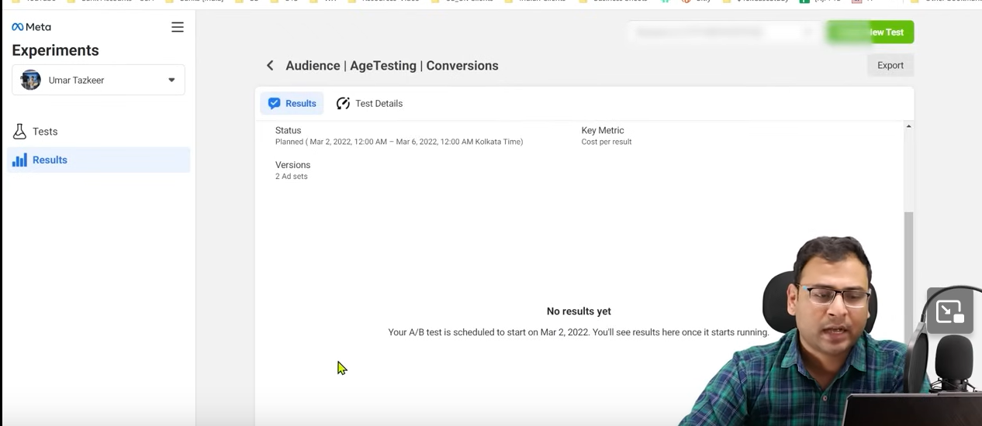

NOw you will see your progress and result as shown above

If any moment we want to delete the test then

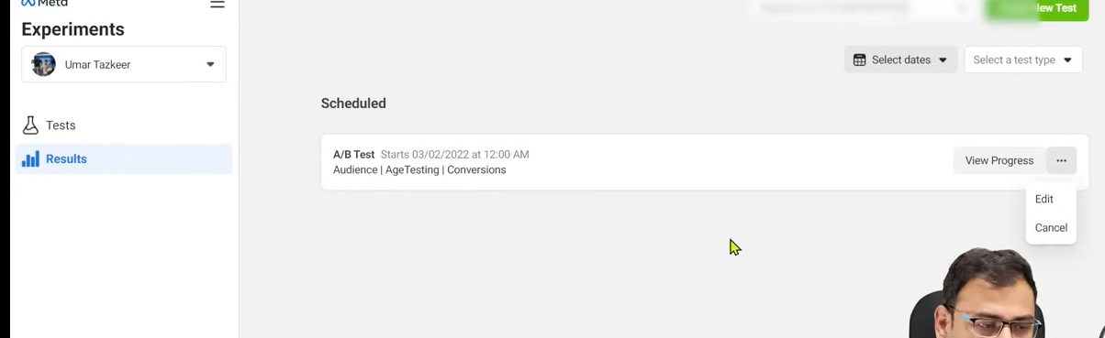click on three dots as shown above and then in submenu click cancel button

Now another way is that in your campaign level you see the option of AB testing there

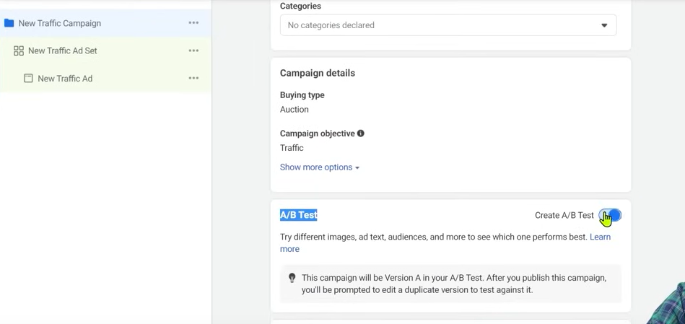

As shown above and when you check the create AB Test and below it it is written that

After you publish it then you will be directed to its different version where you can also publish it and then do the testing

**Note:-**

I think the AB Testing of Campaign is possible

Now one may ask question that it can happen in CBO

Suppose in CBO we add 1000 ruppess to two busget then testing is possible

NO In CBO the budget is not equally get distributed among ad set

And the ad set whoch perform better more budget will be allocated to it

But in AB testing equal resources are used and only one thing gets split uped that Is the audience and change happens of the variable we have chosen and you gets its insight from experiment

In some cases you will think that AB Testing is not working correctly and sometimes you may think that it is not giving good result

So it is very debatable

Because some people use it or some not

It is not like that if we don’t run AB testing then we cannot run ads It is not like that

It is just an additional option in which on the bais of some metric you are cpomparing two things or test it and you can reach some conclusion with the help of AB Testing

**Lesson 86:-**

In this lesson we will learn about **Carpet Bombing Strategy in facebook ads**

SO now we will see what is carpet bombing strategy

Before understand this strategy you need to understand that this strategy is for what type of businesses

From what the teacher has gained knowledge from talking to people and whatever campaign he had run in the past . He has observed that in some cases carpet bombing strategy works and in some cases it doesn’t work but give us loss

SO in such cases teacher has concluded that if you are using carpet bombing strategy then make sure that you are using it for businesses like local businesses like coaching classes which is a local business

Such business which work on a specific area where you want to just target well defined audience(maybe according to area ) you can use this strategy here.

Second thing is that if you think the product you are offering is of a particular people living in a georaohiacal area and has overlapping audience

By overlapping we mean suppose if you are being confused

Suppose you are selling a mouse and you think that people who will buy it can be interested in multiple things so you will target what type of people because you think that in a particular defined area the product or service we want to offer almost all are audience of it means irrespective of the possible interest they will come in all

It does not happen that our product od for everyone It cannot happen

**Phase 114**

There is defined audience for that product that is end user of that product They have some attributes and characteristic but still we believe that our target audience is something like which follow different interests or behavior according to it we cannot exactly target on the basis of some behavior in facebook ad system(because I think of the fear of repeat of audience in different interest) in such cases carpet bombing works but you should have some budget here

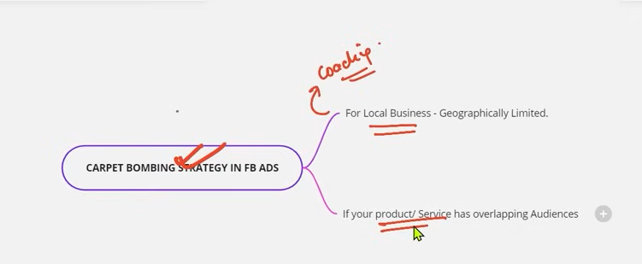

If situation are like as discussed above then there are high chances that it will work for you

But other things also matters like what is your offer , creatives etc

SO first we understand its meaning

Suppose we have local business and it is operating in some geographical area

What we do is open targeting

Which means we do not choose any targeting neither interest based nor behavior based

It can happen we choose age group but they are wide mean we want to target all

And to target all the type of creative we choose is video

Majorly we will use it because on the basis of videos

19:11:30

We have option to make our remarketing audience

By how much our video was watched by what percentage we can make audience on the basis of that

In a way it is a strategy that youbfilter out relevant audience and then you can further target them with your videos and service

This strategy works if you have defined 2 lakh or 3 lakh audience

But if you have audience in crores or if you have such large audience and you target them as cold audience then it is a question mark because then you may need a very high budget

And for that budget you have to run different campaign

You have to make different creatives also

So it should be used for local business or the overlapping audience

It does not mean that you will shut down other srtetegies for this strategies

**Lesson 87:-**

In this lesson we will learn about **Campaign from one account to another**

In this lesson we will learn about by which way we can download campaigns in ad account and how to push it tin another account

Basically we are saying that we went to copy campaign or creative to another account then how we can do it

These may be small things but it can increase our productivity if we use it correctly

We will see how to do it practically

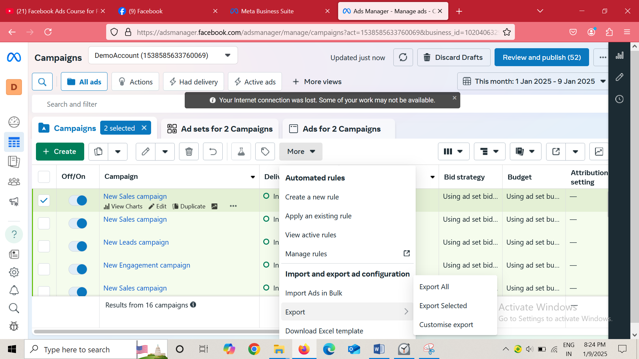

C;likc the campaign you want to copy and paste select it by checking the checkbox

Now click on more button and then in submenu go to export and then to Export selected

And then a new window ill oen like below

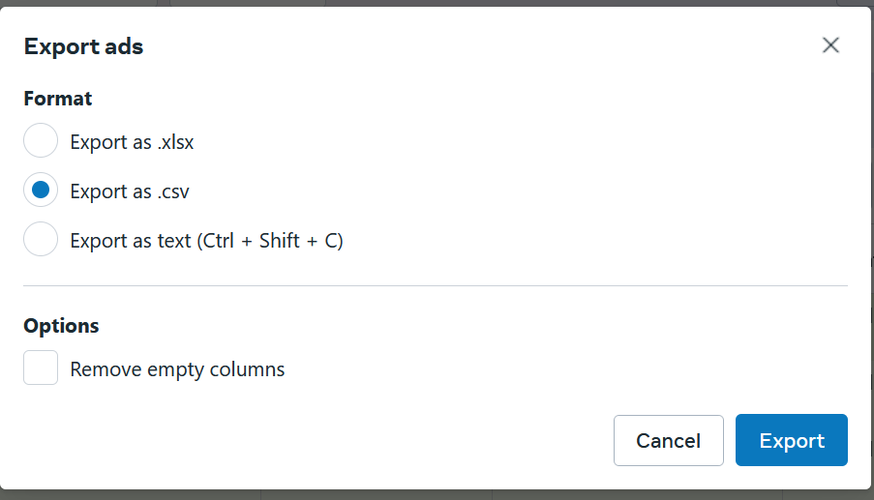

Select the Export as .xlsx and then click on export button

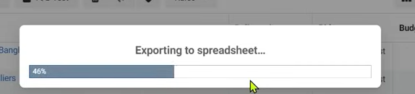

NOw it will export it

After exporting it you have to do one or two changes

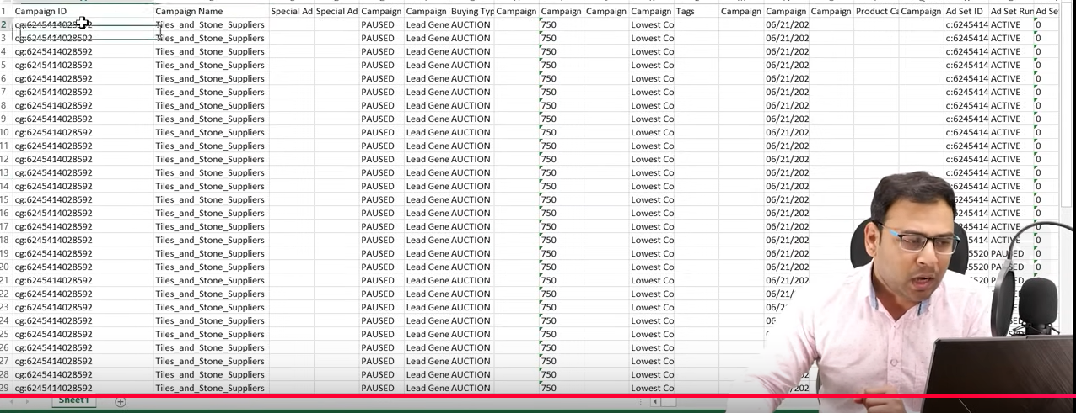

SO now remove all the campaign id and then Ad set ID because in new ad account all these things will be changed

Remove Ad id and then save the file

Now we will upload this sheet into another add account

By going to more button and then to import Ads in Bulk

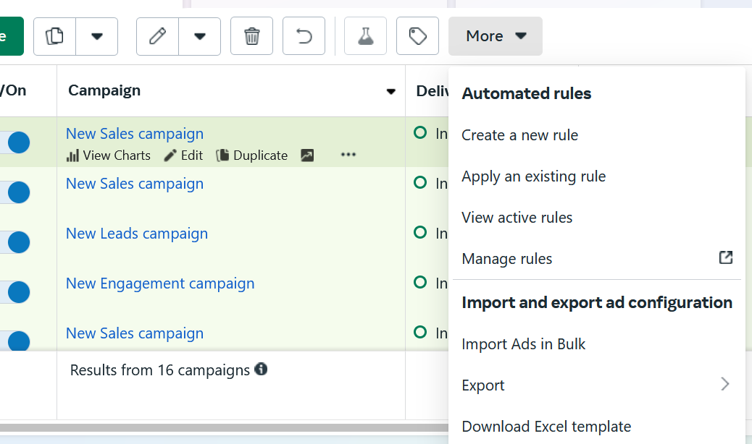

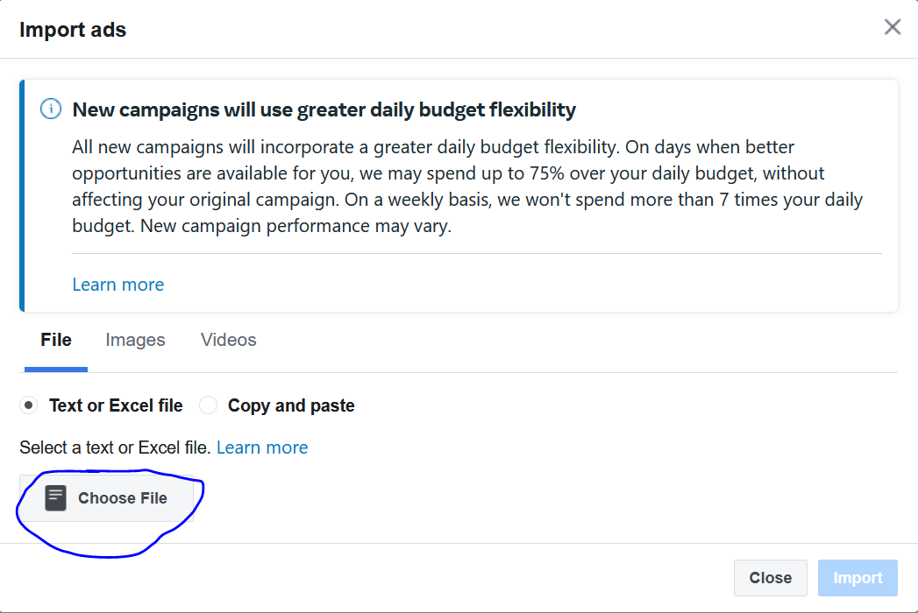

Now abiove window will be opened and now click on marked area to choose file to puload

After choosing your file in your file browser and then click on import button

It will take time depend upon the size of your campaign and your all the information related to the campaign will be uploaded to it. Now your campaign will be uploaded there

That’s How the campaign will go from one account to another account

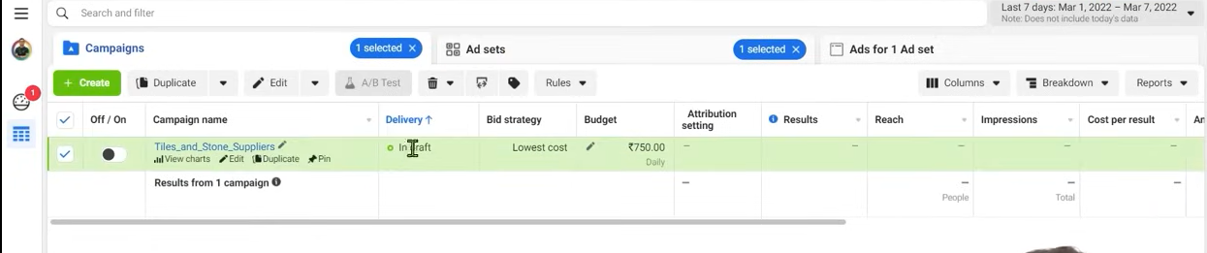

Now you can see the campaign above

The uploaded campaign will be in draft

You can bring some of youe=r changes here

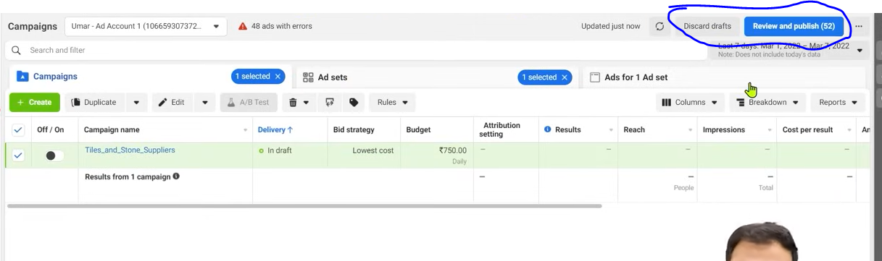

You can either descard it or pulish it

These small things we will keep in mind that we will use in future and our productivity will increase in future

**Lesson 88:-**

In this lesson we will learn about **Learning Limited Status in Facebook Ads**

Many people always have doubt that what is this that we see after our ads (who knows)

And if it remains learning limited then how it can affect out ad set performance or campaign performance we will discuss it all in this lesson

We will see differet type of status at ad set level or campaign when we run our facebook ads

Whenver you run your facebook ad set then you will see first the status that is learning

As the name suggests you know facebook ad system on the basis of data

The more data will be in facebook ad system

The better way the data will be collected by adset the more better performance we will see In future

SO initially the data is not captured that much in a defined time period then you ad set is in learning phase and we have to move away from learning phase and you have to understand this as an advertiser that if your ad set is in learning phase then you will get better performance there From learning pahe you have to bring them to active phase

By active we mean that our ad set is data rich and whatever it needed it gets it the way it wants to understand it has understand it

Now that particular ad set is working to its full potential and it is now giving you better results So your fast task is that your ad set is data rich and they come out of learning phase Suppose learning has whatever criteria is

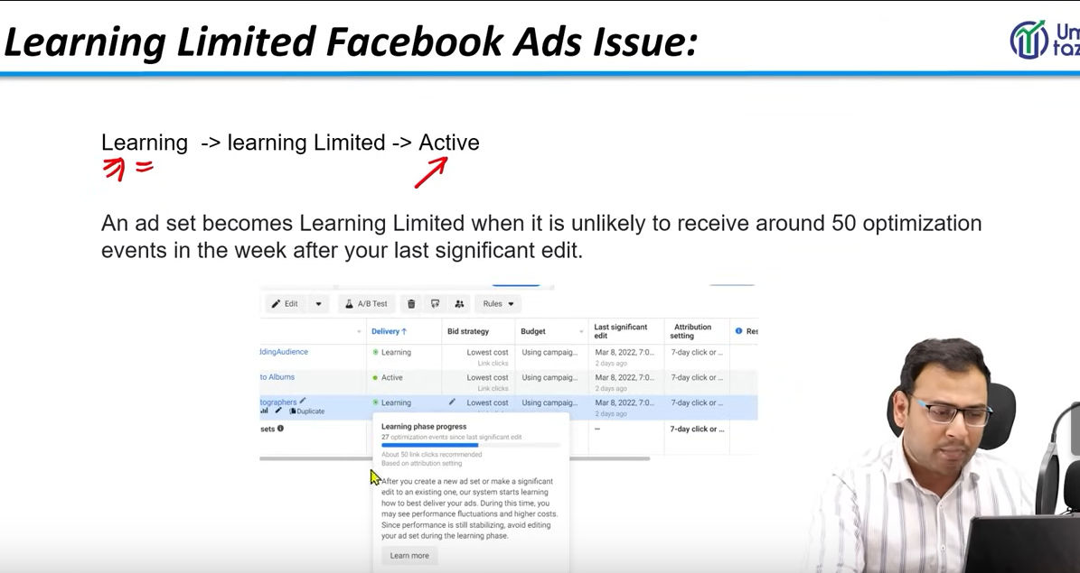

The tooltip as you see above may be when your campaign is running and you hover over it then you see the state it is in

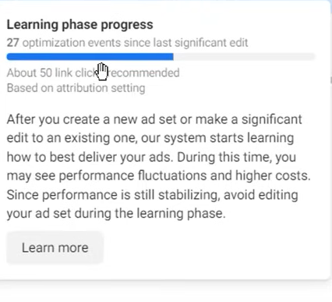

Now he tool tip is saying is that you are in your learning phase and it is saying that you needed 50 link clicks in one week and you have only 27 link clicks and time has also not completed do it is in learning phase

If in previos one week whatever event it is optimized for if it could not happen then your ad set will go to learning limited

And it is also written that



By optimizing event we mean if we are running a traffic campaign

**Phase 115**

In facebook ads and optimizing event of traffic event is link clicks

Whenever we run traffic ads tehn we wat that we get more and more link click

So if we doesn’t get 50 link clicks in 1 weeks after last significant edit then our data does not have proper data and it does not come out of learning phase but to limited learning phase

As advertiser our work is that more fastly bring ad set out of learning phase

Th reason behind staying in learning phase or limited phase can be many

If we try to understand it that How we can come out of learning phase hten we have some solution

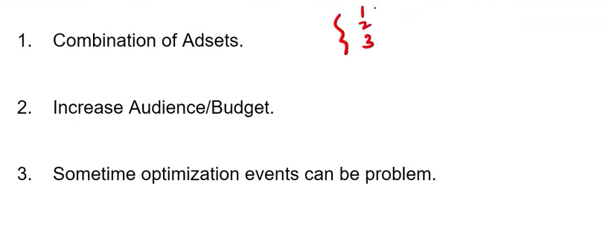

First is combination of ad set

Suppose if you have multiple ad set each targeting different ad audience there is too many division and in respect of it in cpming of optimsing event may take time you can also doi these that if you have different ad set and have different budgets allotted ti them then you can combine them

Increase budget/Audience

Measn if your learning is very slow becaue your event s are being triggered very slow

You can increase your audience more people will see it there are chances tjat your optisation event also increases or you can also increzse the budget

Third point is that sometimes we choose wrong optimisation event that is not gonna happen whose data is not coming So we have to keep in mind that we need ot choose righrt optimization event and we can also do some experiment around that we can choose correct optimization event

The more fastly we reach the active state the more better way our campaign will be optimized

**Lesson 89:-**

In this lesson we will learn about **Detailed Targeting in Dead**

Sometimes ago there was announcement from facebook that they are going to remove detailed targeting options and over the period of time they removed it

There were many targeted that we used to do targeting previously but we cannot do it noe the official announcement was on 9th Novemeber where they told that

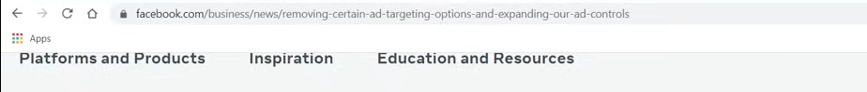

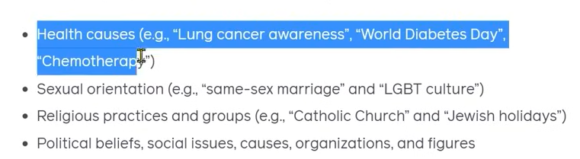

In the above categories there was some interest which fall uinder it and they have removed it means now advertising cannot target them

But the question arisies that the advertiser who were doing it previously now what they can do now

What suggestion facebook ads give

If there was an interested in which you have targeted and it is removed from facebook then the facebooks ad give us some suggestion to solve it it just give us interest alternatives but it is not that relevant according to teacher

It is very I portant to know because there were many business which uses the interest that was removed from facebook ads and they get good performance also and they were like that did not needed to be removed means less controversial interest

Because they were removed advertisers face many problems

There adset were gets shaken

This lesson is important because from march onwards

Your adset will have to be removed which were using these interest

For example oin teachers ad account

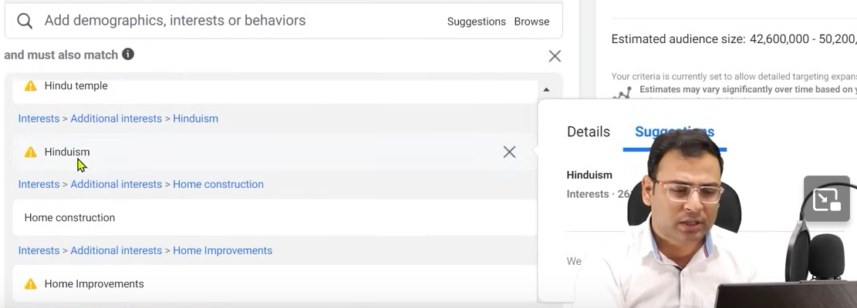

There is interest related to Hinduism it can be controversial because it is a religion due to which no uggestion is shown when we hiver over it

As you can see suggestion in non controversial interest as shown below

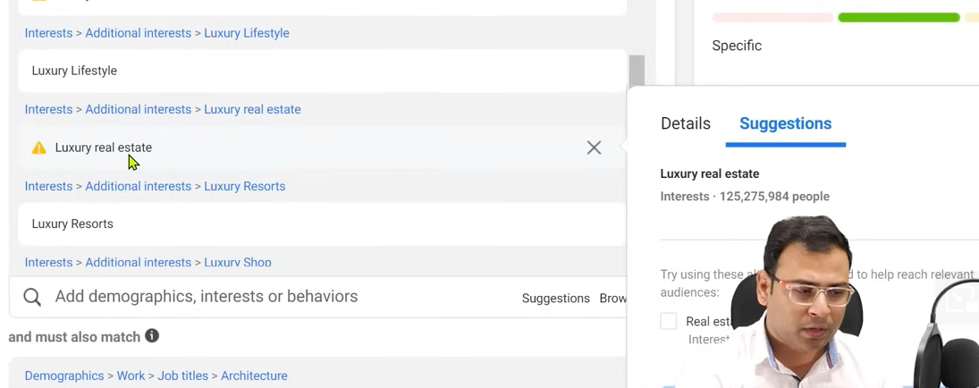

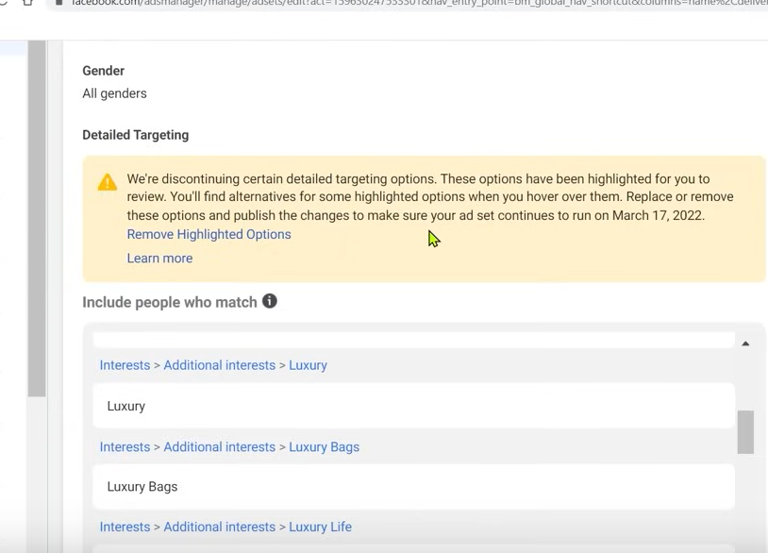

Whenever you choose controversial targeting then you will see above yellow box notification

It is saying recheck your adset oitherwidse your adset will be removed till March 17 2022

If you click on remove highlighted option then these option will be removed

Alternate may be provided by facebook ad system

Another option we have as an advertiser is that if you have already has a data in the form of custom audience then you can make custom audience lookalike audience

Then you have scope to make lookalike audience interested in contversial topic removed by Facebook

But the point ids facebook is not bringing some other things do you have to work with the interest available in facebook and you have to renoce this option definitely you campaigns may shaken but without this you don’t have other option

If you click on Learn more in yellow box then

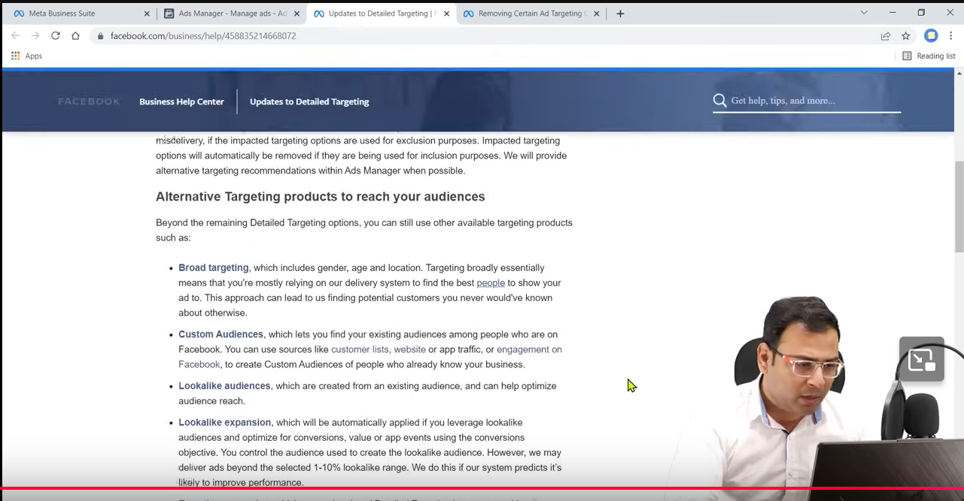

Now you can see updated for detailed targeting

What it is recommending that should do broad targeting . You go to custom audience , lookalike audience , you do your targeting expansion

It is the same thing teacher recommenede about custom audience

Aftert this you can expect your result

Definitely there will be problem in your adset but that’s how it works and if they bring updates then you have to believe it

You have to be cautious while targeting cold audience through detailed marketing

You have to focus on it

**Lesson 90:-**

In this lesson we will learn about **Publisher List Facebook Ads**

We are going to talk about Publisher list and if we want to understand that when we run our facebook ads then those ads run on top of which pages or videos in pages whereour ad will be shown

If we want to take reporting of it all then how we can understand it

When we run campaign in facebook ads or crete ad set then we get the option of selecting the pklacement we select the placement there for example we chose in article placement or we want in between the videos our ad will be shown

But in whom videos our ads were shown and in between whom video our ad can be shown means can we get some publisher lists

By publisher we mean where our ad will be shown

Suppose there is a video in page A and that oage is monetised then definitely in betweent he videos ads could be shown dependinf on whether that video fit in our targeting

That page will be our publisher and we became an advertiser that’s why webare running ads and the publisher is an identity where our ads are shown

Can facebook give us publisher list from which we can know that here are so much publisher in facebook menas in these different pages our ads can be shown

Where our ad can be shown it is actually publisher list

But it is not important that you ad will be shown to all publisher you r budget can be low or targeting is slow it can happen that .It can happen that you have selected different interest

It is not important your ad will bwe shown in all publisher so you have to understand that we are running ads for 10 days or 15 days I want to know where my ads are shown on which publishers they are shown

If you understand these all things you need to go to Business Manager or business setting

And now go to Brand Safety

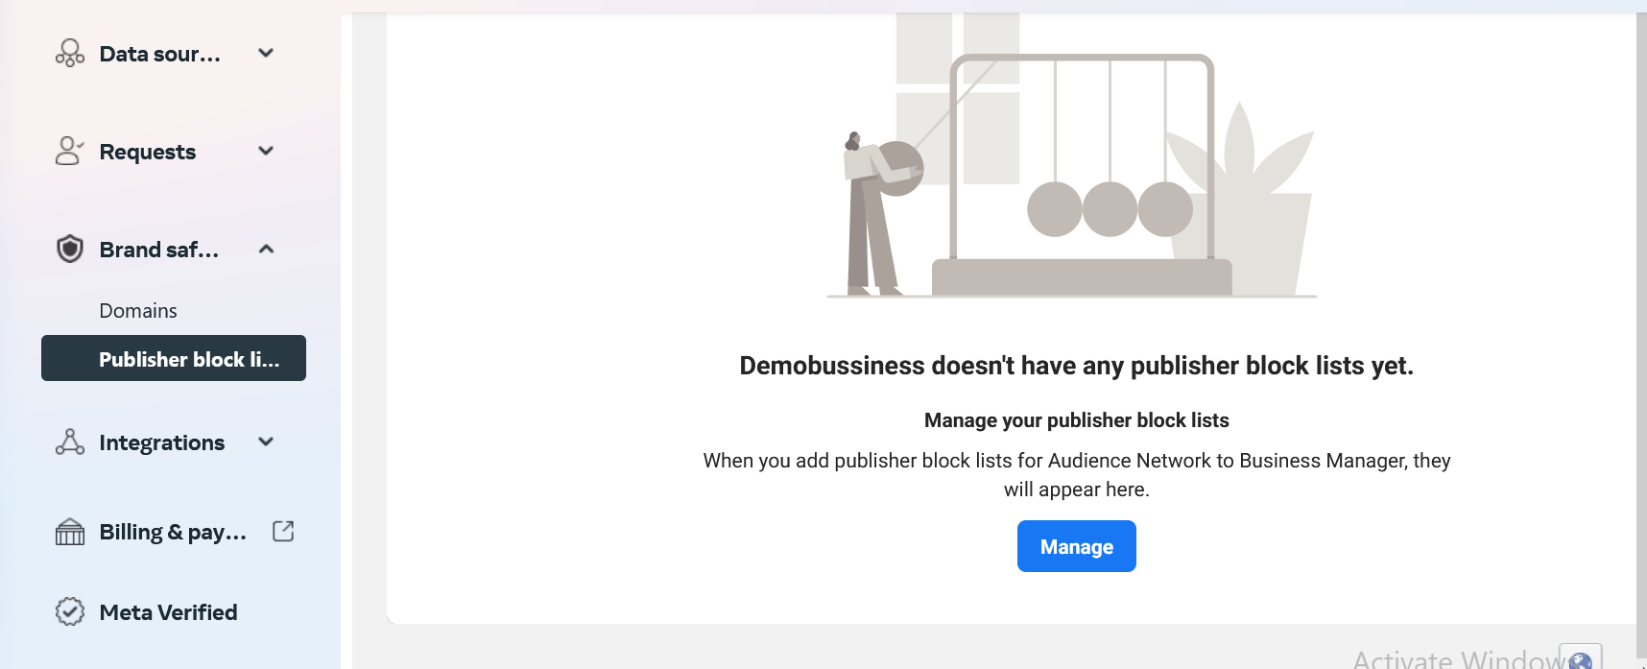

And then go to Publisher Blok list and hten click on Manager button

**Phase 116**

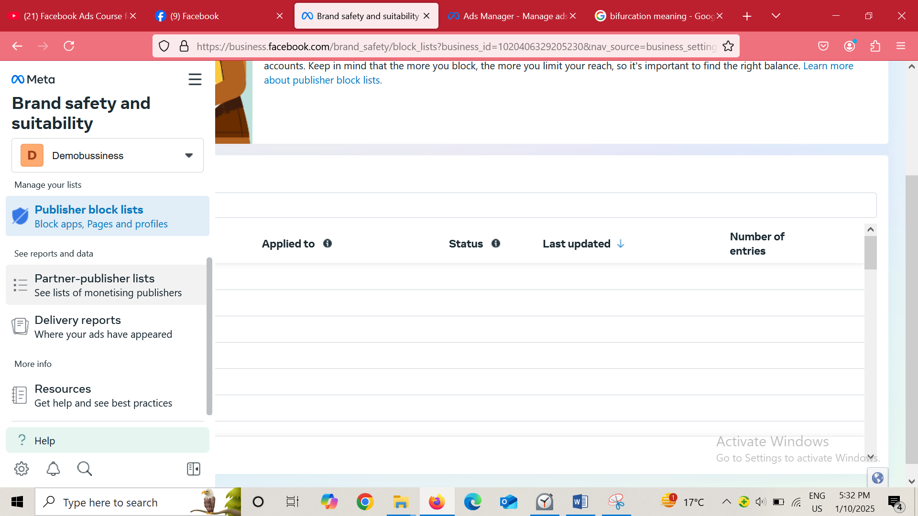

Now we will go to Partner Publisher lists option in side menu

An then now in main windoe it will look like below

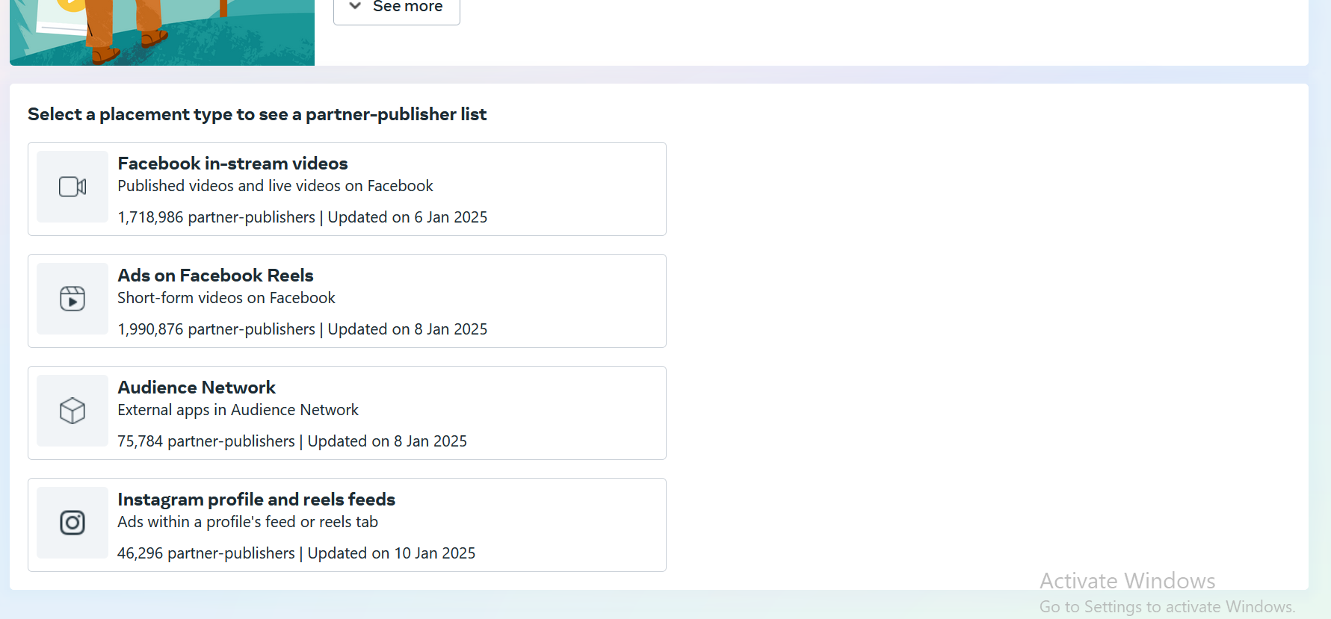

You will see a list of placement click on any of them to see the publishers related to it

As shown below

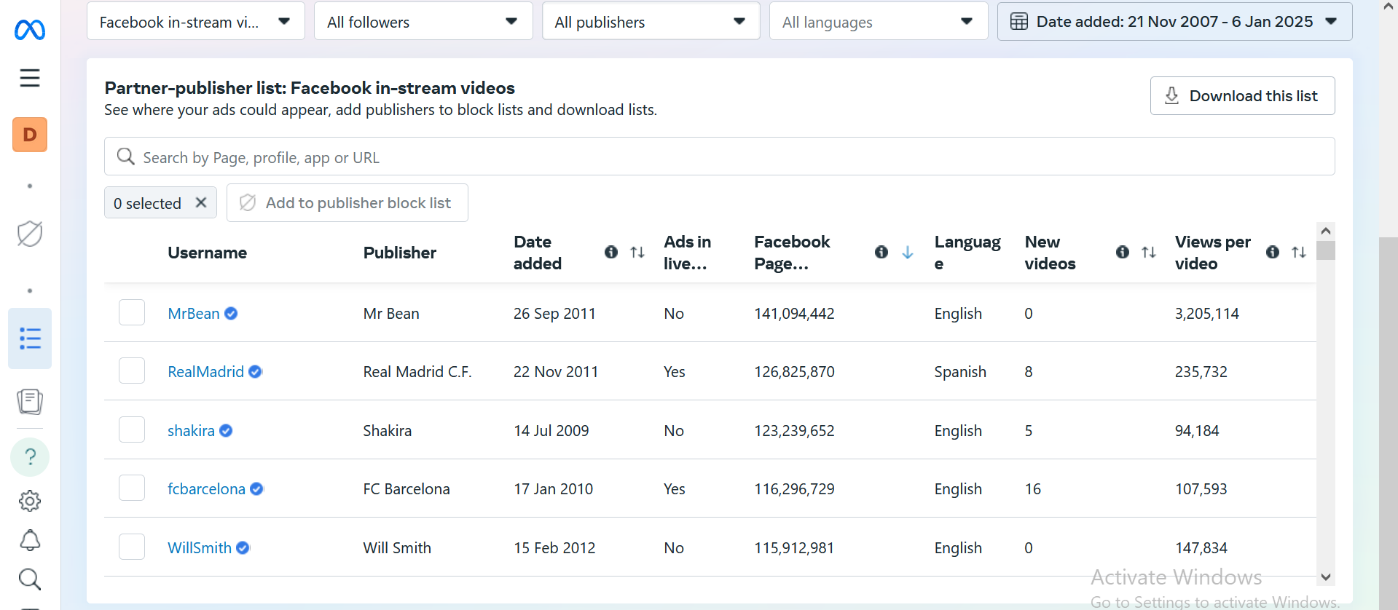  
SO now you can see many publishers are given there where your ad couls be shown

You could see ther einformation for example we see information of MrBean you can see when it was added,Are Ads live on it or not and how many facebpok follower he has etc

You don’t need this information in detail because publisher list is very huge

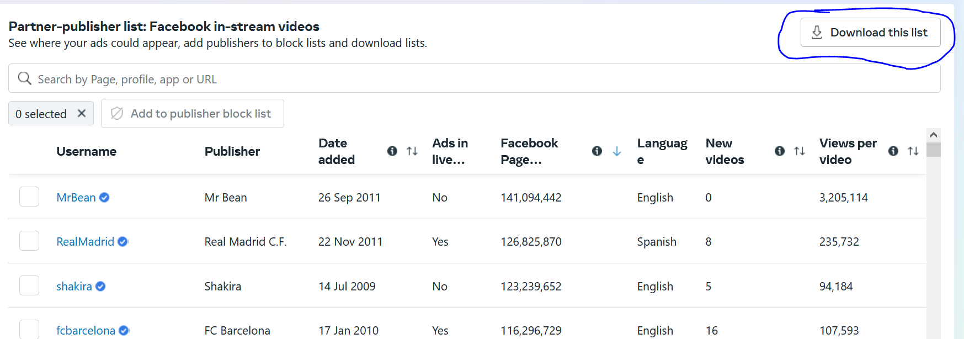

You can click on Download this list button to download the list

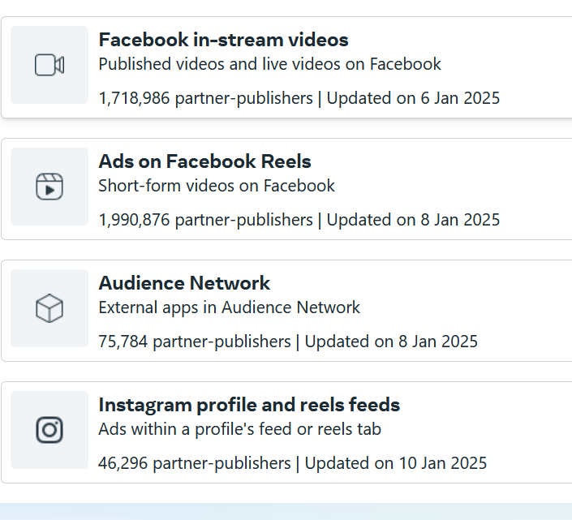

You can see that each placement has their own publishers

And now if you want to see that where your ads were actually shown then you can go to delivery reports in the side menu

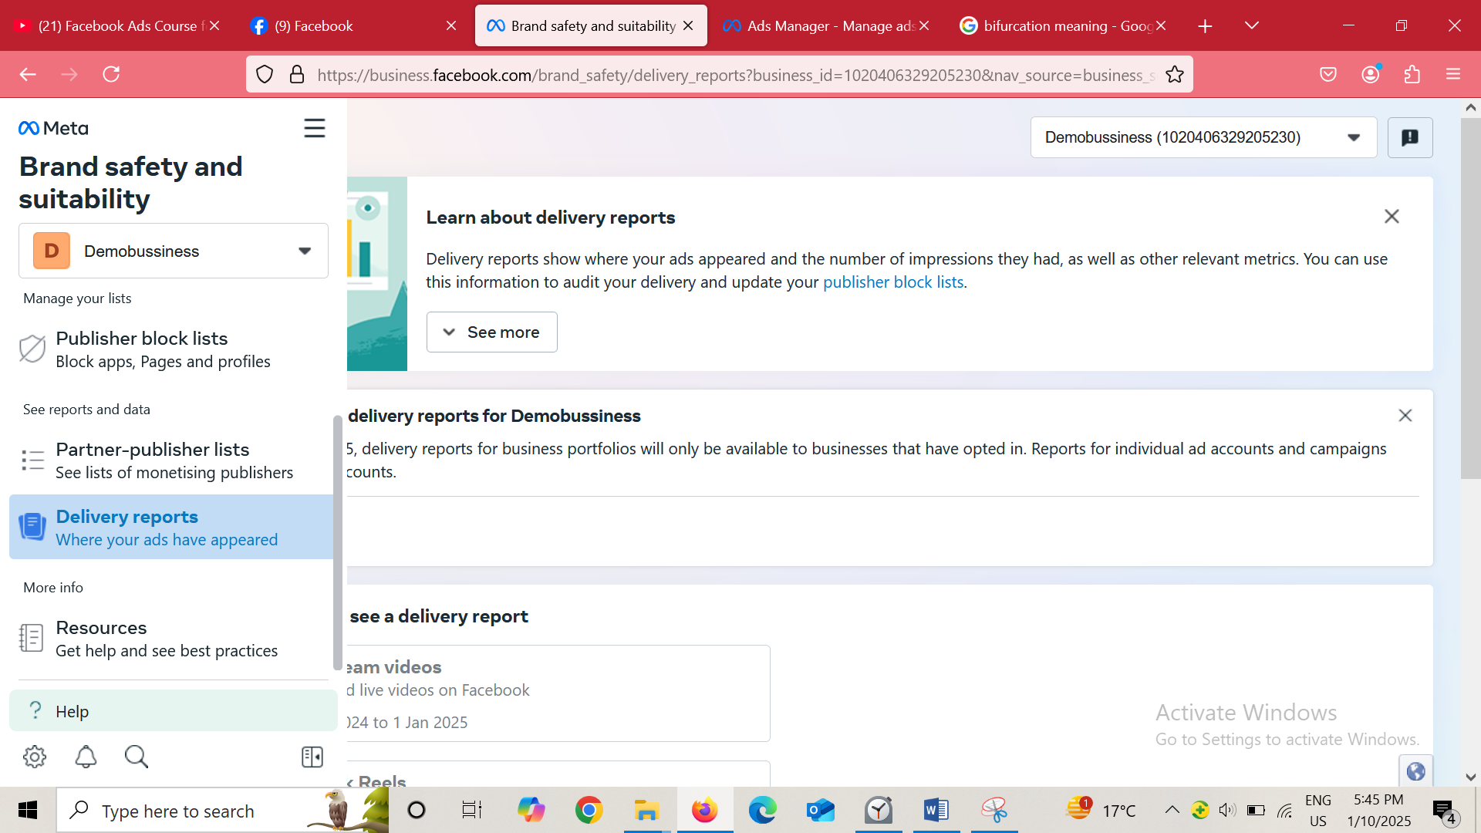

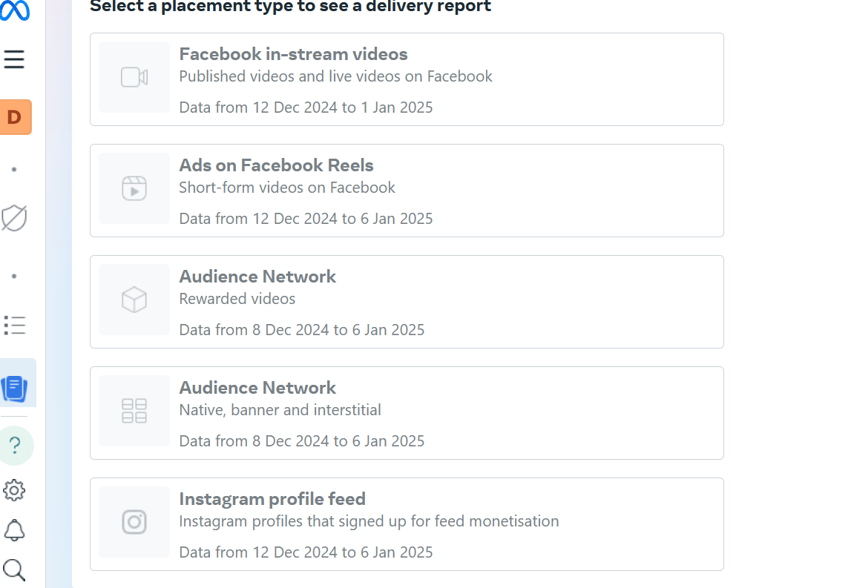

You can click on any placement type and then there publishers will be shown related to the placement you clicked on where your ads were shown

Now from Teacher POV

Teacher select Facebook Instream video nad then you can see the list of publisher where his ads were shown

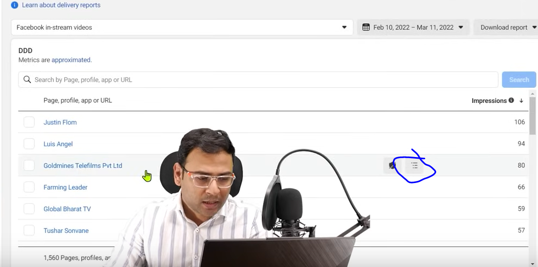

IN corresponding to each publisher you can see there number of impression the ad give there

And if you want to se more in detail that I that publisher in which video your ads were shown then you click on marked above area and then you can see that in detail you will see it when you hover over it

That button is called content level breakdown

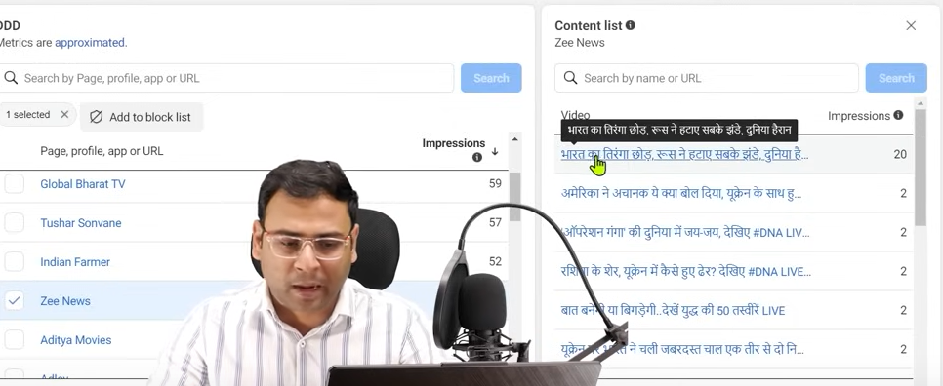

Now you can see the video where ads were shown in the right side

And with each b=video here is corresponding imoressio which wee on it

If you think that a particular publisher is of no use of yours then you can select it by checking its checkbox

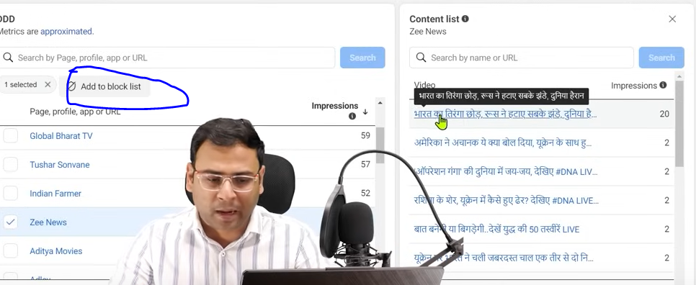and then click on Add to block list button as marked above

That’s how you will review it or study it that whre your ads were shown

There are many reports that we don’t give attention and ignore it bit onteh POV of optimization they are very important but hthis list very big due to whoihc many people ignore it but this is important you hould also see it

Now you can see how they work

**Lesson 91:-**

In this lesson we will learn about **Facebook Ads reporting**

Whenver we want to make report in facebok ads then we get a tool inside it as reporting with the hep of which we can create different type of reports according to our requirement

But If we talk about reports in facebooks ads or in general we talk about it then basically they are of two type or levels

Sometimes reports are needed by internal team many times we wan to analyse our data or give presentation of data in the internal team then in that particular case we need better report

So we need it if we are doing analuysis in our internal team or internally analyse our campaign for better performance there we need it So this is the use case of reports or tools which we will talk about second case is which is more important and many people use reporting for it that is actually for client you have also need to send the report to client

How you will create that report and how you can send the report to the client

We will see it through facebook ad’s ad reporting tool

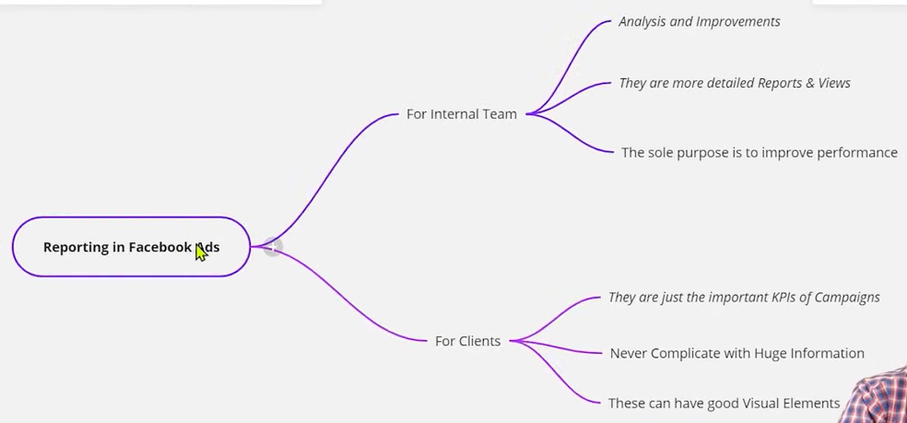

So for internal Team we need it for Analysis and improvement

And we need to make it in detail nor some regular report so that we can do better asalysis in our internal team or we want that out campaign should perform better so for those things we need reports

When we talk about client then they are just important KPI’s of strategy

When you are sending report to the client then you should not do like giving a lot of metrics to the client dur to which the client get confused and you also get confused

And the data which was need to give to client also gave it to him

By not giving dta does not mean that you have to hide something from it

If you want totell the convergence to th client then tell the convergence

But if you talk about other metrices like impression , reach etc then the client will get confused and the major thing to see in report the client will not see it because work of client is not analysis it is not his work to see the detailed report and then do the analysis and then give suggestion on the basis of it you brin changes in your campaign this is not work of client but of your or agency

For client report is what work you have done and the KPI that was decide have you met them that is actually reporting for client

So you will not give detailed report to client only show what is necessary

It will be good if you represent your metrices in graphic form for client it will be easier for the client to understand

NOw we will see how to create report

Now go to side menu

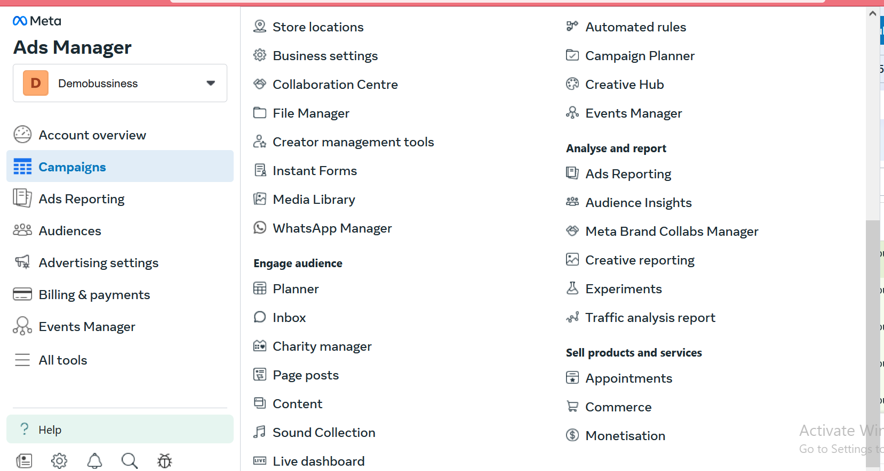

And then go to all tool sand then in Analyse and report section

You wil see two major type of reporting therethat is Ads reporting or creative reporting

Creative reporting is more important because how the creatives are performing

Many times we separate campaign analysis and createives analysis

That’s why facebook has given separate sections to study your creatives and then anslyse your creatives for the betterment of your campaign and strategy

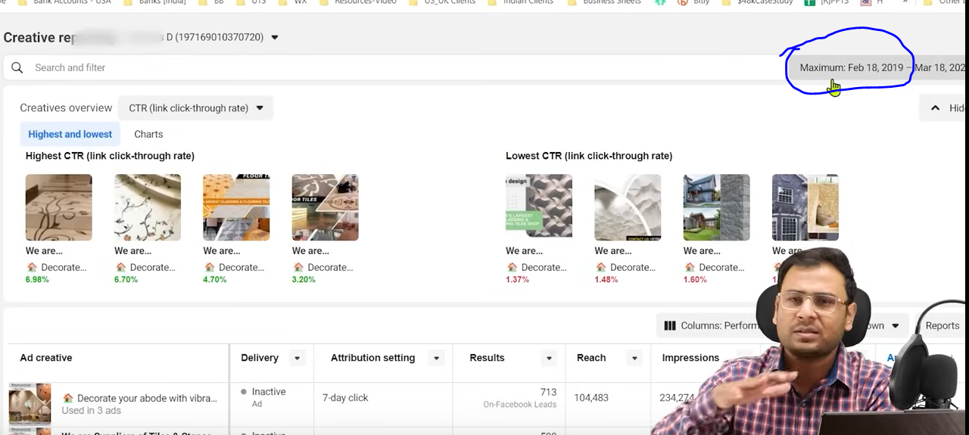

The marked area tell us to select the timeframes

To see how our creative performed during this time period

But when we say createive performance then you must have juge on the basis of some parameter

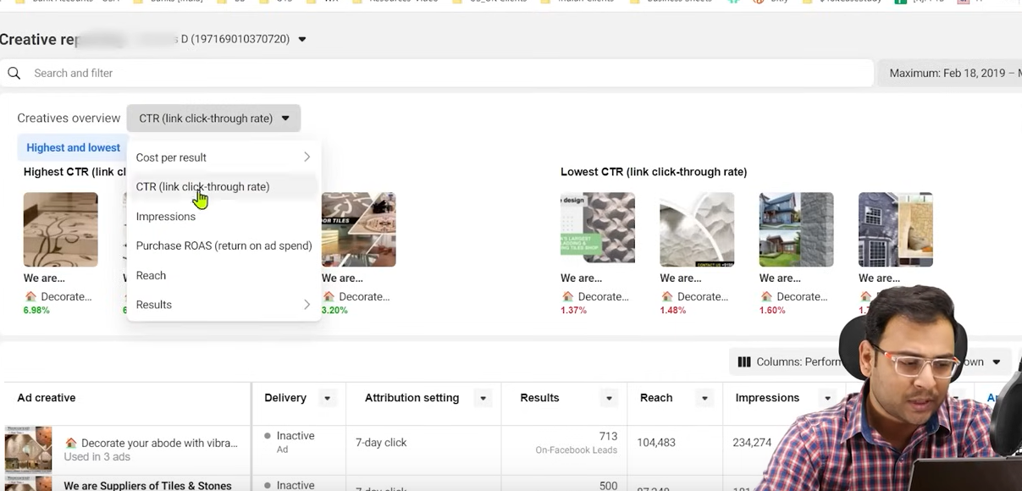

By default CTR is selected we can see our metrics such as Impression , Reach etc

What are our creatives

On the left side you see creative giving good ctr but on the ight side you can see lowest CTR

If are usin many creatives then it becomes helpful for you

So that you can understand how your creatives are performing according to different parameter that we can select as list shown above

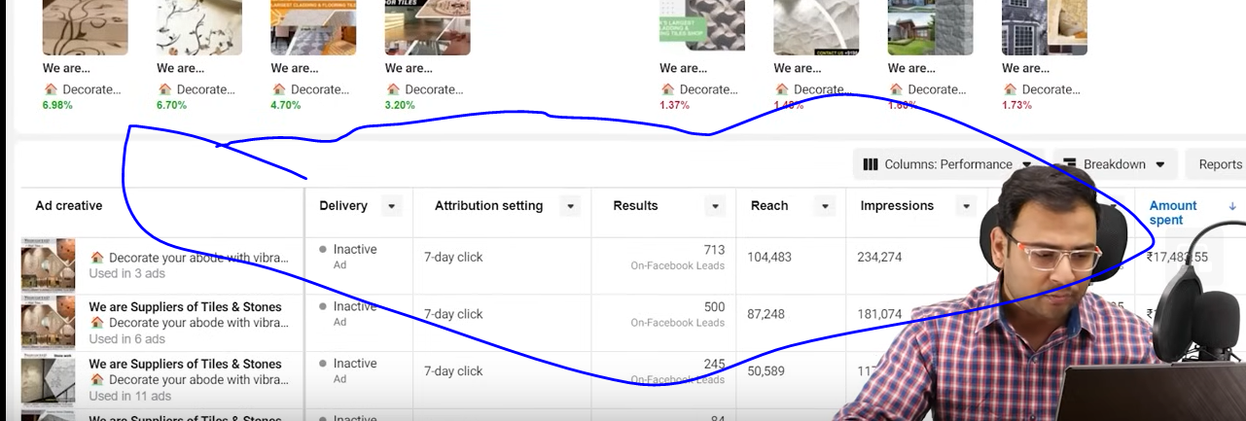

Now you can see the table as marked above to see the different impressios of the creative

But you see the major highlight above the marked now if you want to do analysis and reporting at creative level then this is the option through which you can do so

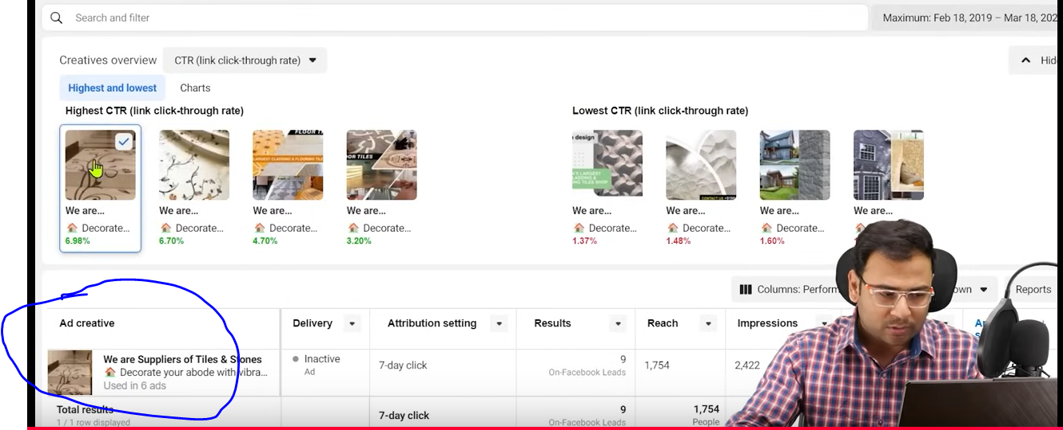

Now if we selwct a creativd like the teacher do then you can see its details in the table as marked above

You can also add other attributes also for more detailed analysis

You can also see it month by month

As ahown below

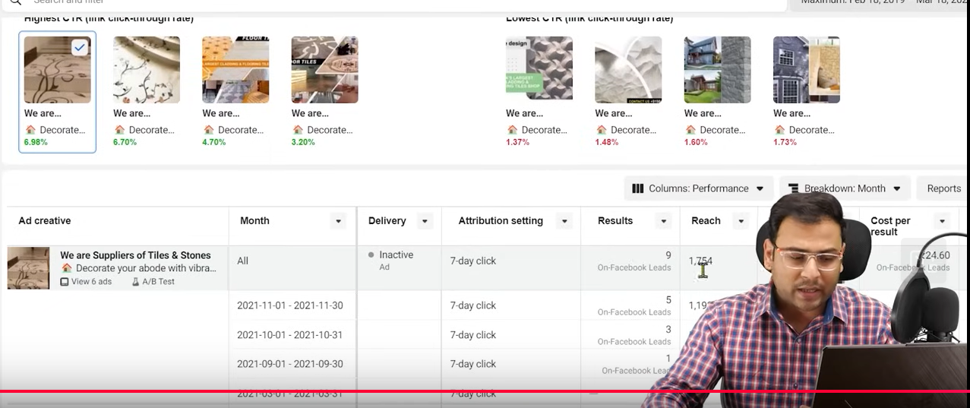

So here you can find your winning creative

As the teacher tell us in facebook ads you have to treat creative analysis diferent to other analysis

You can also download these reports I your pc and export the detail where your information is given

**Phase 117**

The second this is ads reporting where we see detailed ad reporting option

We ne dot understrand some things

Reports are made of two things one s our dimenstions and another is metric

If someak that through which campaign you get how much click

So campaign is actually dimenstion and click is actually metric

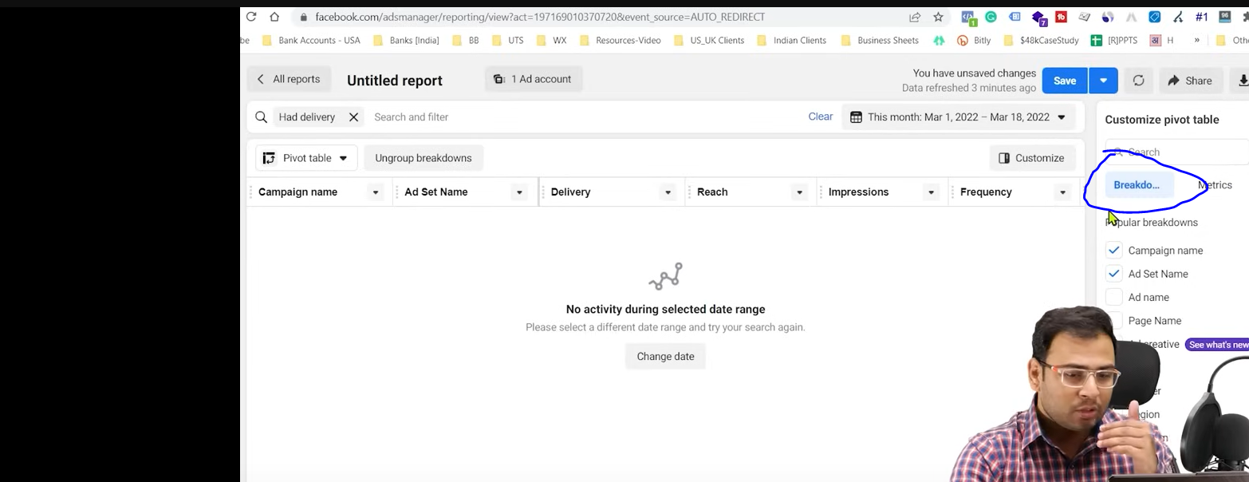

So here the report is brken down beteen metric and Break down as marked above

The dimenstions we are talking about are actually the dimenstion

What report actually contains is answer to some question

When some say report then they may have question and you need to answer it

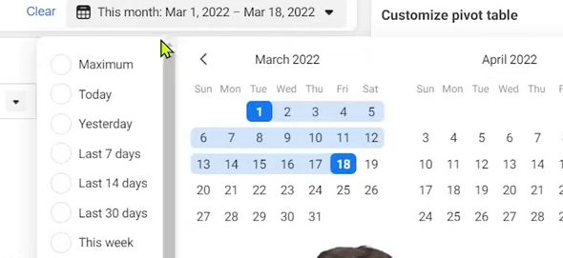

Lets formulate our own question

Lets say we set the break down to campaign name

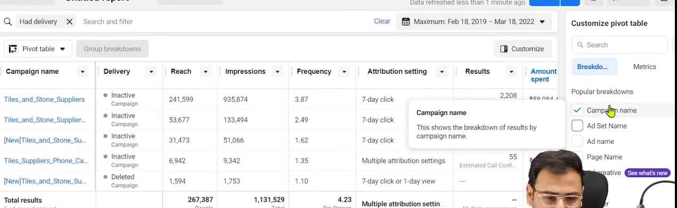

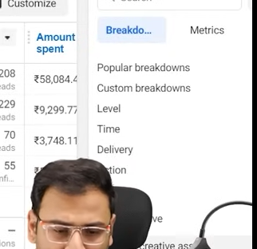

You can see different option on the basis of you can do breakdown

Like you do in action like what was the destination (who knows) ,post reaction convergence device here you can select different breakdown

AS we have selected campaign name

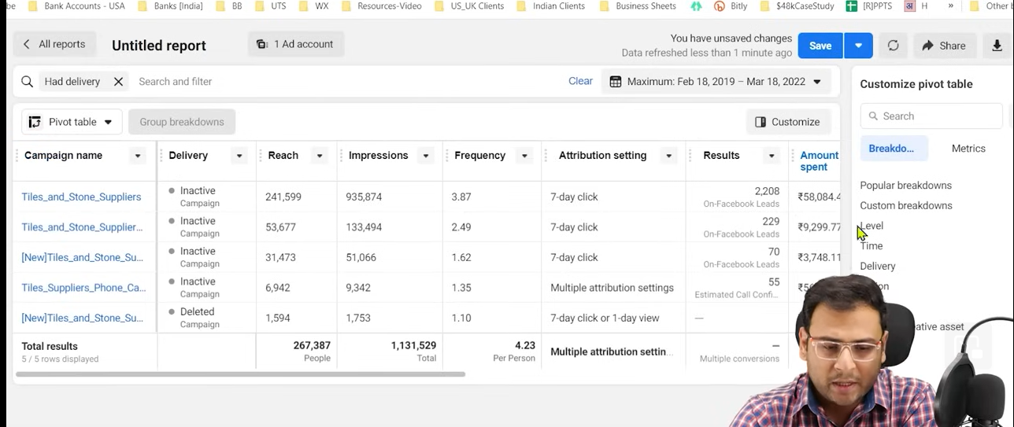

And according to our campaign name you can see your metrics like Delivery, Reach, etc

Now ther are some metrics which we don’t need

We just want to know resulr or cost per result

Now we just will go to metrics

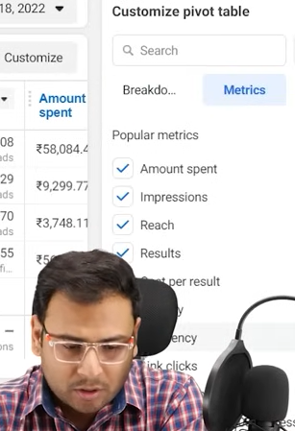

And now uncheck the thing that they don’t need

You can drag the column and relocate it in the table

Another way to remove a column is by going to the column and then click on the marked area as shown below

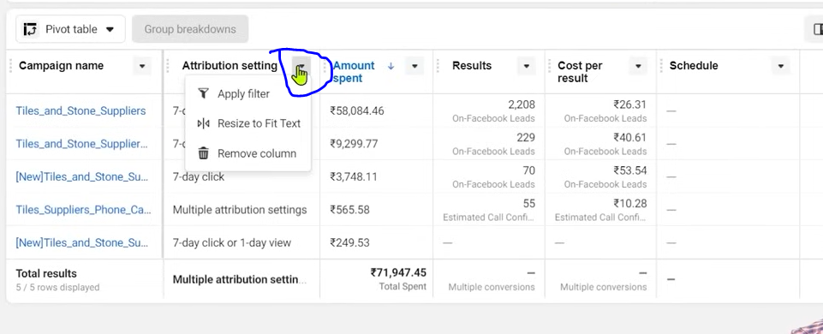

And then in submenu choose remove column

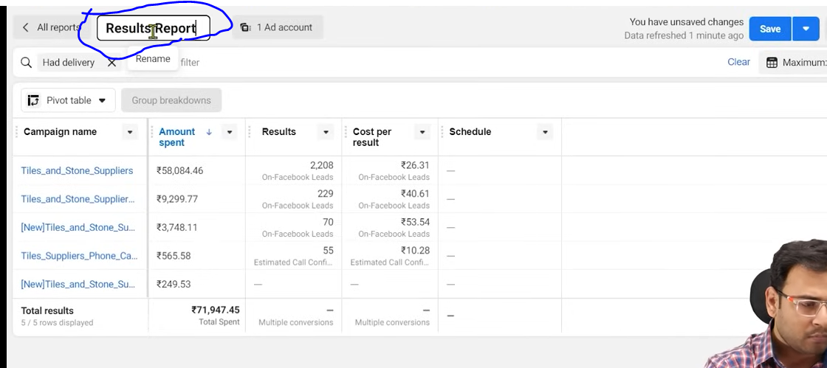

Now you can see the report is vey simple and in maked above you name the report.

Now you can click on save button to save the report

Now when you save the report Now click on All reports button present in the top left part of the screen

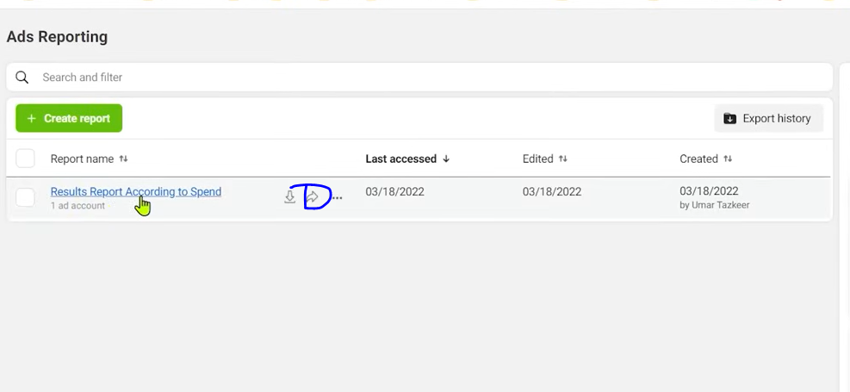

Now you can see your report listed above in Ads reporting

Now if you want to share it then click on the marked area as shown above

And then a window will appear like below

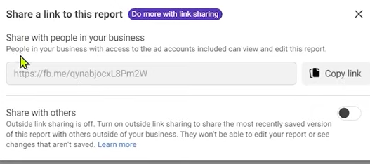

Now click on copy link button and then give this link to the people you want to share with

Now if you want to download the report in excel format then

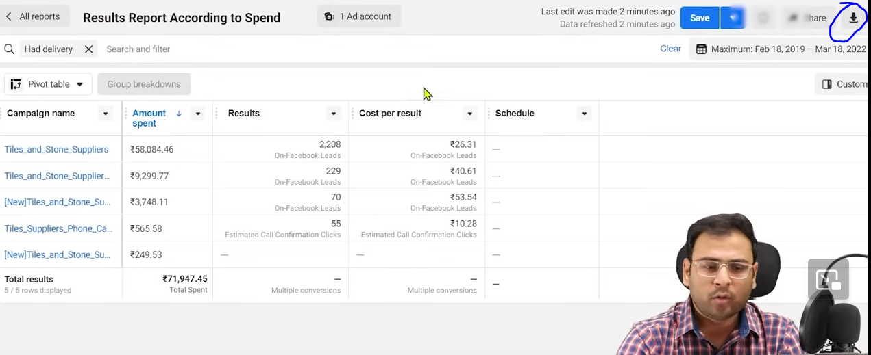

Click on the marked are and then a new window will appear

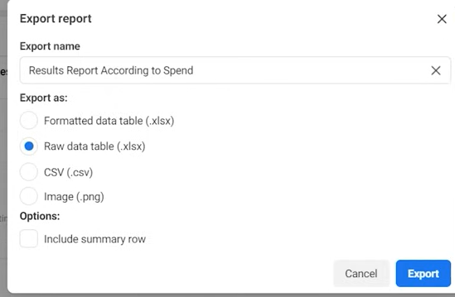

Now you can check the Include summry option to include the summary option and then you can download it by click on the export button

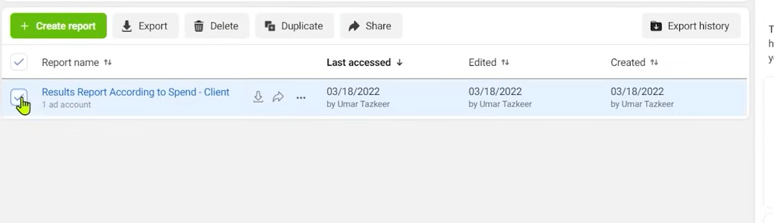

If you want to create report then click on create report button as shown in green color

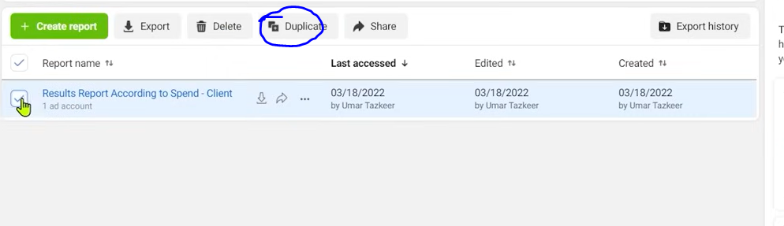

NOw if you want to duplicate your report then check the report you wan tot duplicate and then click on duplicate button as marked above

And then a new window will optn like belo

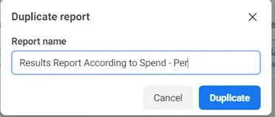

And tell the name of the duplicate report and then click on Duplicate button

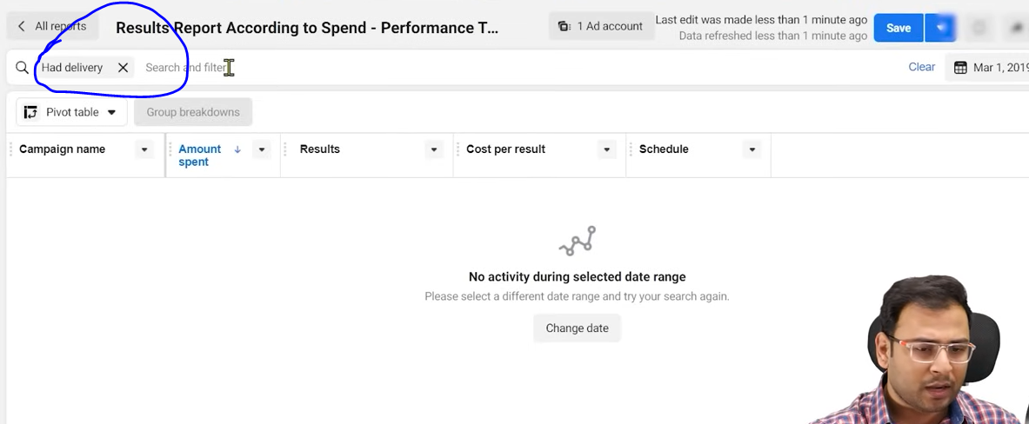

You can now filter it accordingly as marked above

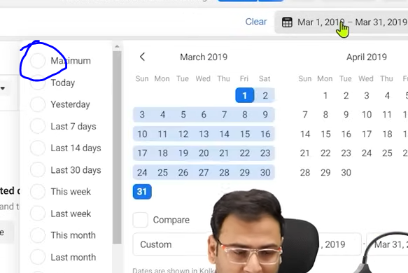

Now if you click on the maximum radio button to see all you data of the date range where you data exists

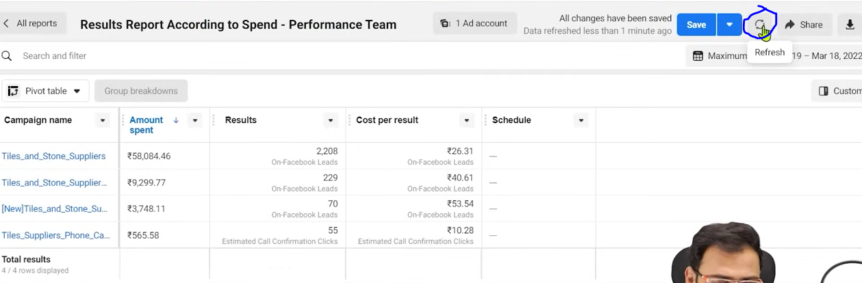

You can click on marked area to see your data real time by refreshing it

Sometimes it happens that we make reporting beforehand because we need easy things so we come to reports and start watching it to know things which are important thing for us

We don’t want that our changes in real time campaign

We come to reports we see things and then do analysis here and do drag and drop to do further analayis

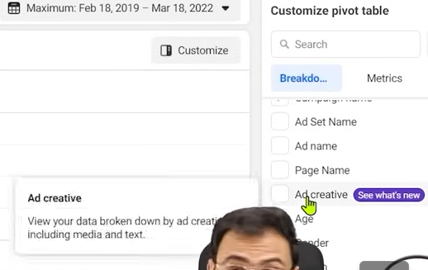

You can see your Ad creative information in your campaign

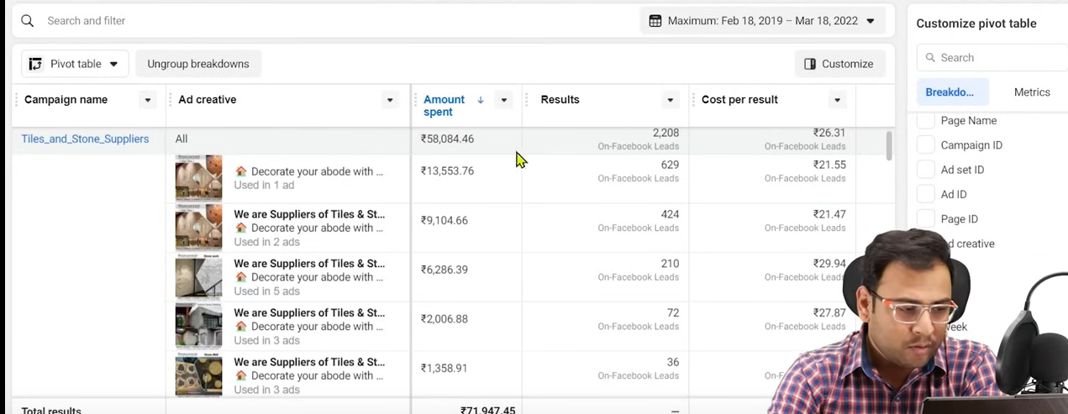

After clicking on it you see the interface like above

You can see the performance of creatives in the campaigns now

We can change the look of the interface by clicking on the marked area below the search and filter field

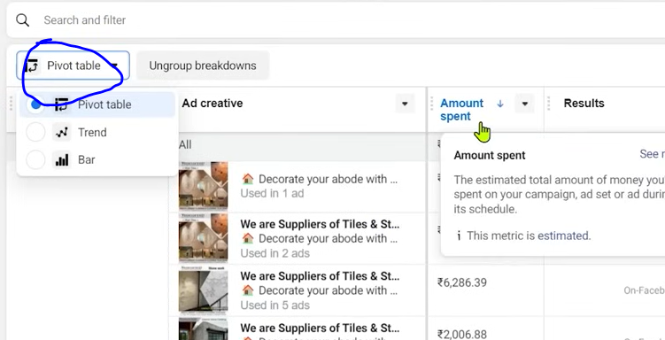

We ususally go for pivot table we rarely choose Trend or Bar,

We download it and then color it and then make a template we use it if we want to send it

The more practice you do means the more dummy reports you make the more analysis you do the more question you will develop in your mind like we want to understand Campaign’s adset and its creative result the more question you will formulate by your self the better you will be able to use reporting facility

Lesson 92:-

In this lesson you will learn about **FB BluePrint Certificates**

We will study that what is the blueprint certification of the Facebook and how we can get this certification

First we eed to understand two things

That certification in facebook is paid and the learning resources are absolutely free means if you want to get certified then you have to pay some money and then your exam will take place and if you pass it then you will get certification

But to crack the this exam the learning material is free and is public

These things exist in Facebook but such thing does not exists in Google

We get learning material free and the certification related to Google ads are also free.

If we want to access the learning material of facebook then we have

To go to facebook bblueprint .com

<https://www.facebookblueprint.com/student/catalog>

Facebook call its certificate facebook blueprint

IN interface you will see many menus like

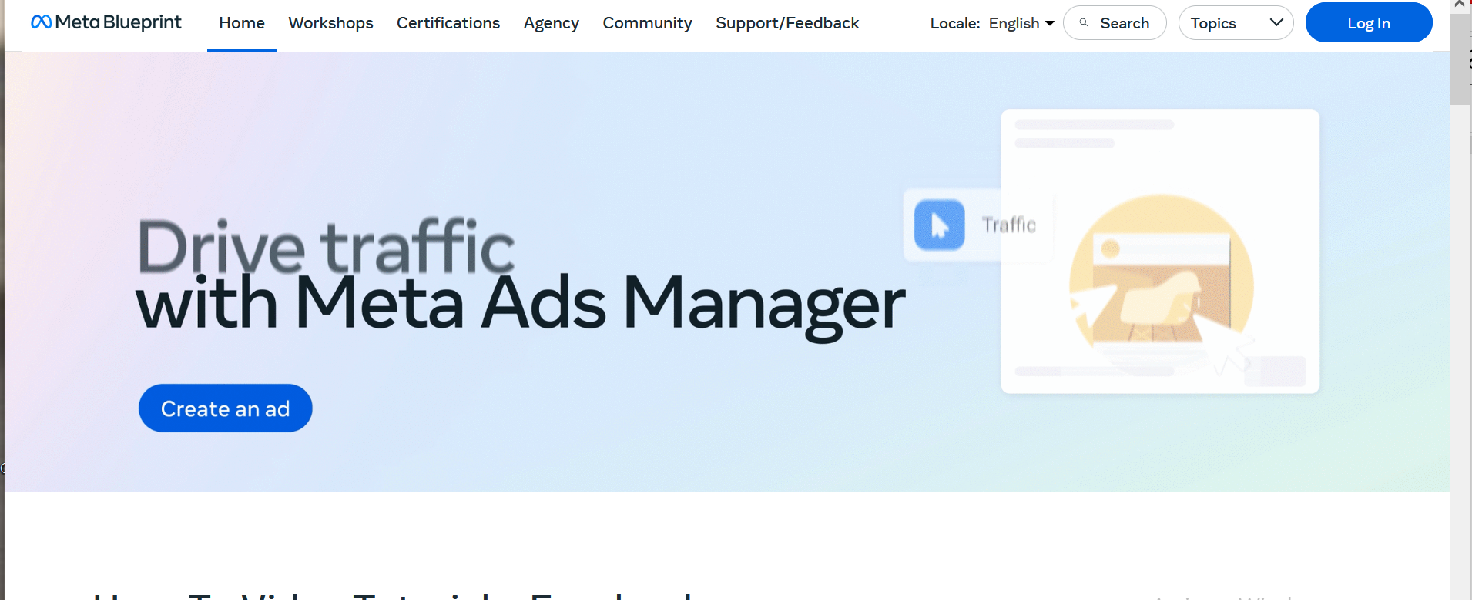

Home, Workshop, Certification, Agency etc Now we will go to Certification

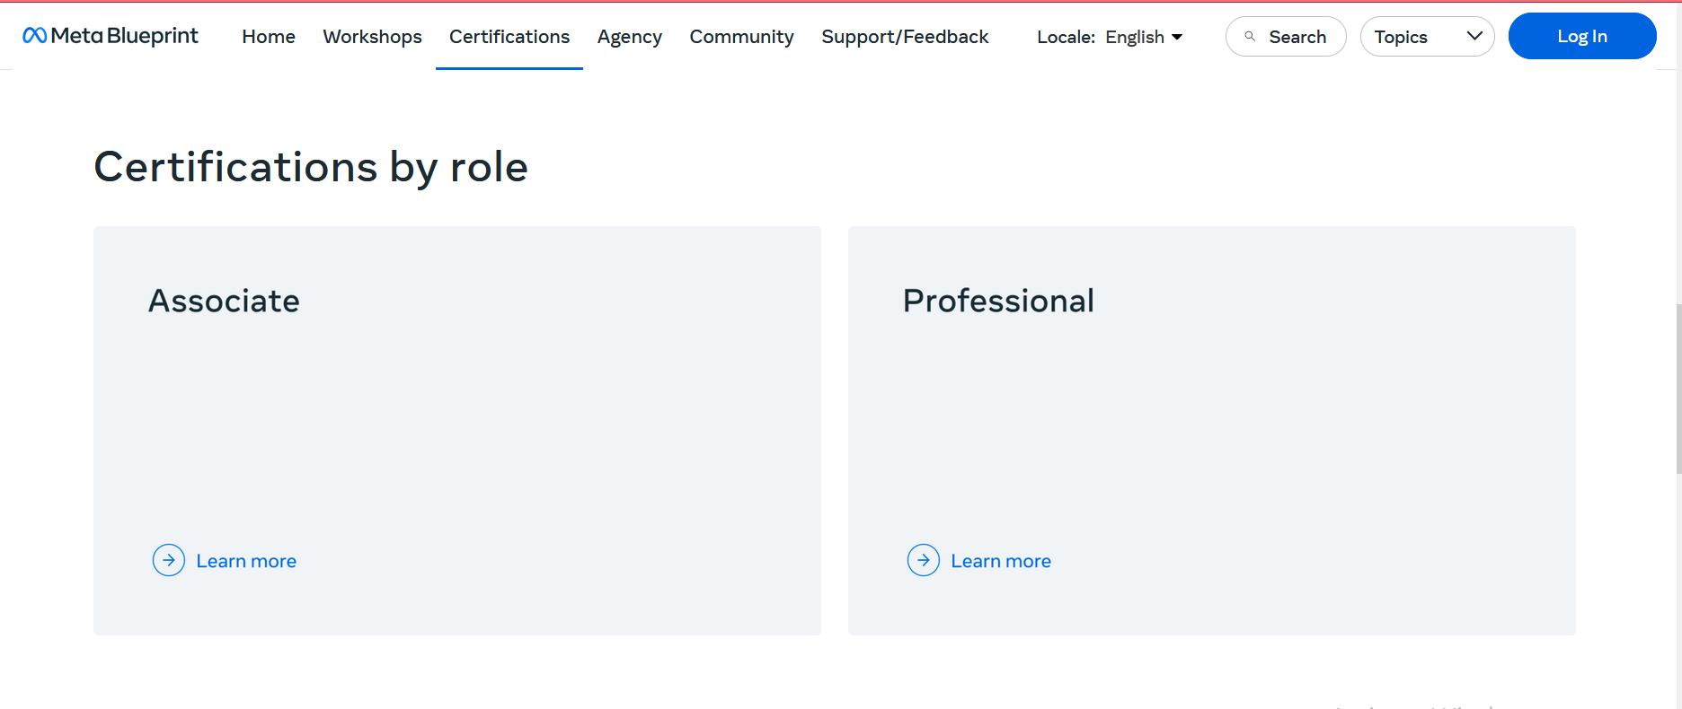

NOw you will see there different certification according ot the role

It is not like that certification is only for Facebook media or whoever who run facebook ads

There are other roles that facebook provides certification of

Like From Teacher POV then it also provides certification for developers

But we will talk about marketing certification

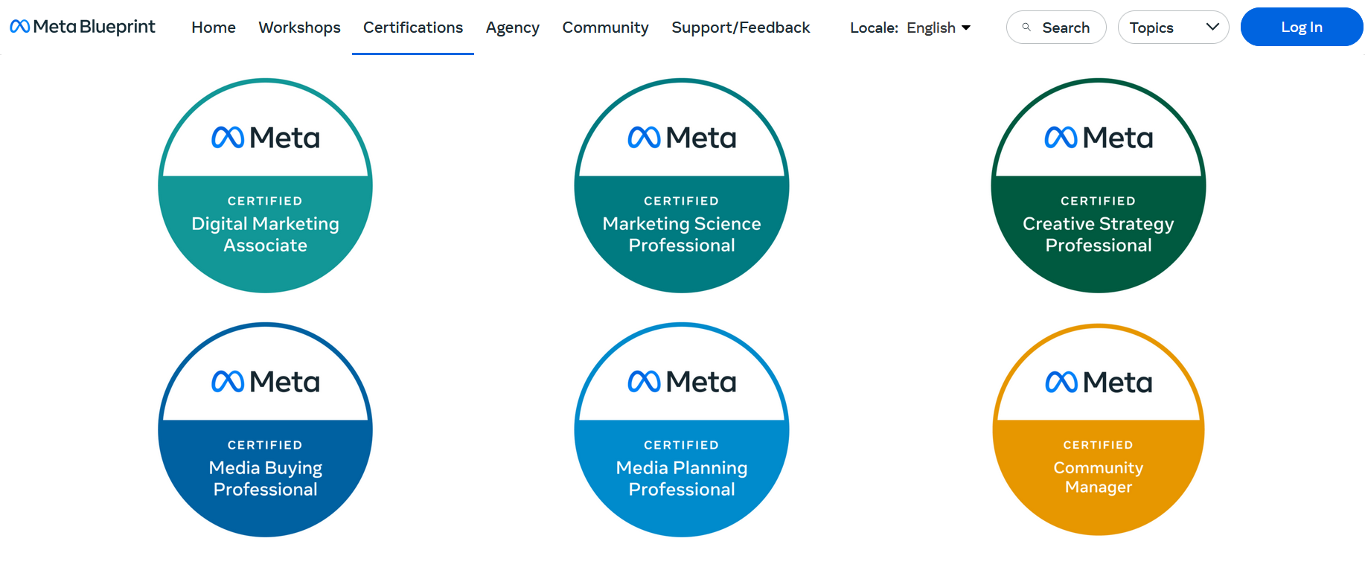

Now if you go below then above will be shown

Now if we go to Digital Marketing Associates which is the most basic and you will also see Marketing Science Professional

If you want to go for marketing then you can go for Media Buying Professionals or Media Planning Professional

And you can also go for Marketing Science Professional

**Phase 118**

which is related to AB testing

Market Developer is different (from Teacher POV) which is good if you are interested in API

If we open any certificate then you will know how you will get the certification

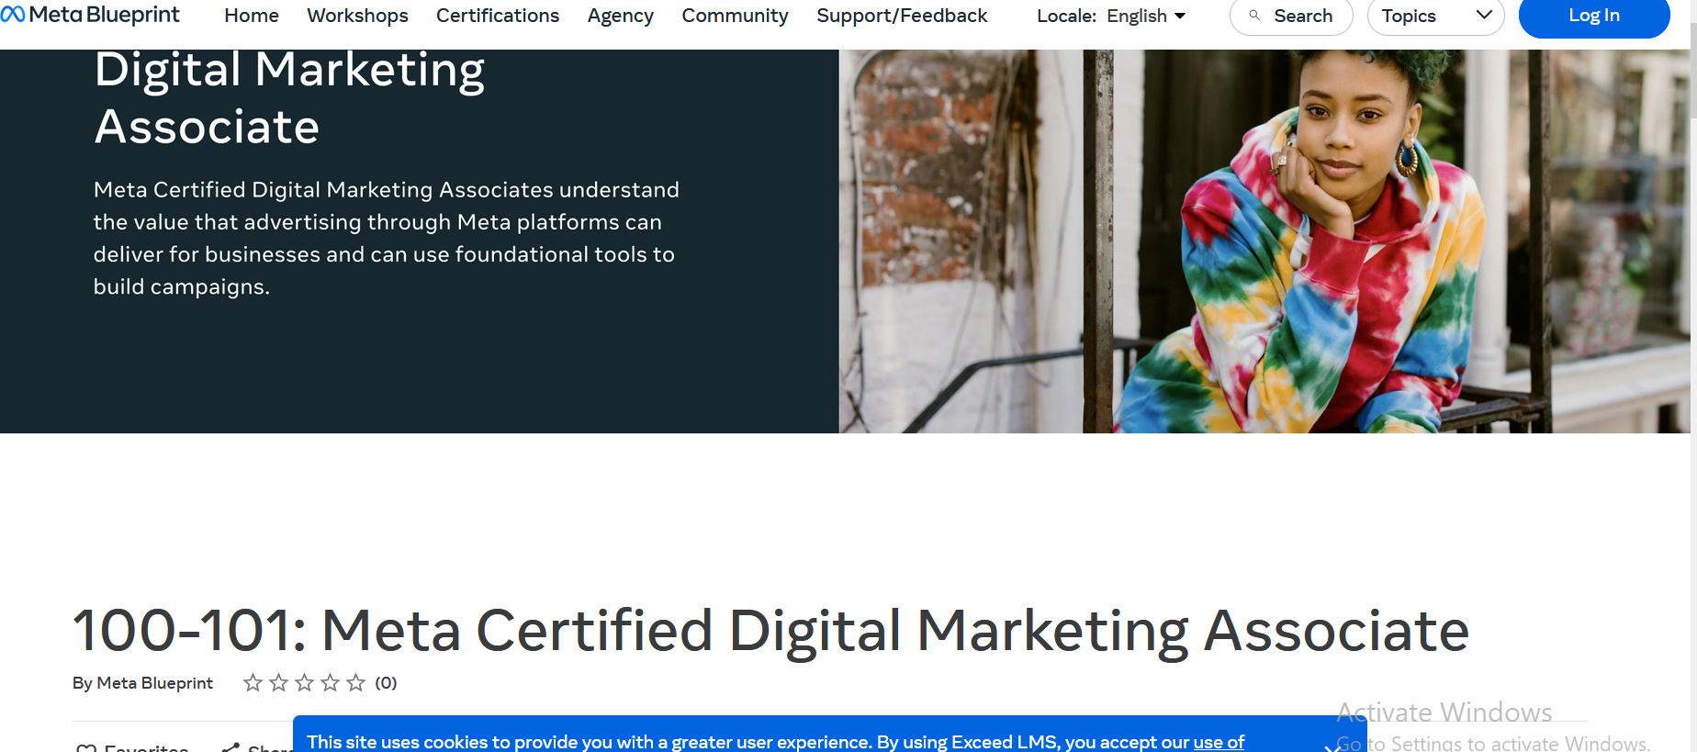

SO we open Digital Market Associate course then you see above

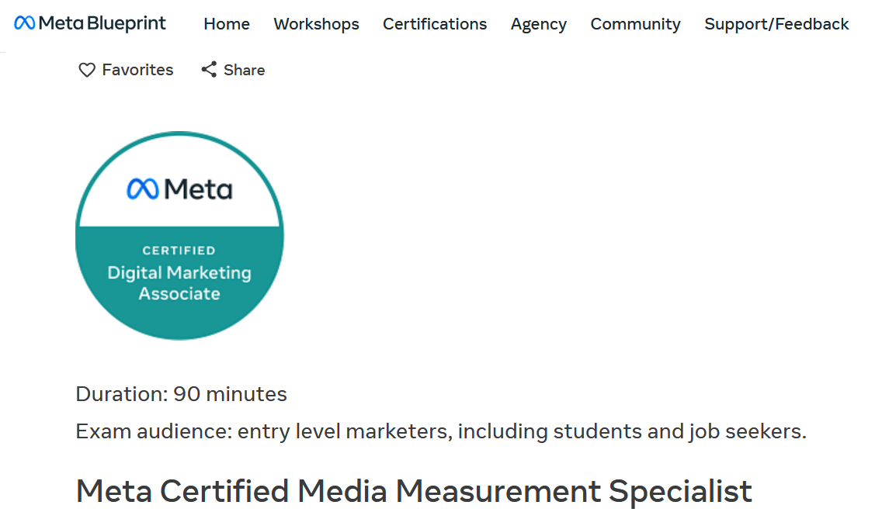

Now if you see belo then you will see exam is of 90 minutes

You can see it is also written that this Certificate is for the student , Job Seekers, entry level seekers etc

If you are already working in agency and your ads are working perfectly and you know how things work then he don’t thing that certification can give you any value because if you switchin jobs then they will not ask you that whether you have facebnook blueprint certifacion or not

They will ask you what you have achieved before it how you run the facebook ads

But on the other if we are taking interview for fresh role then and two candidate come in front of us and one have facebook blueprint certification and other have not both are same but the certificate person may be given more priority by believing thing are constant in both of them

SO if a person have facebook blueprint certification then we can say that the person may be series that’s why he has certificate he knows his path or road map , he has become certified and he needs a job now you may have seen that what is its imprtancve

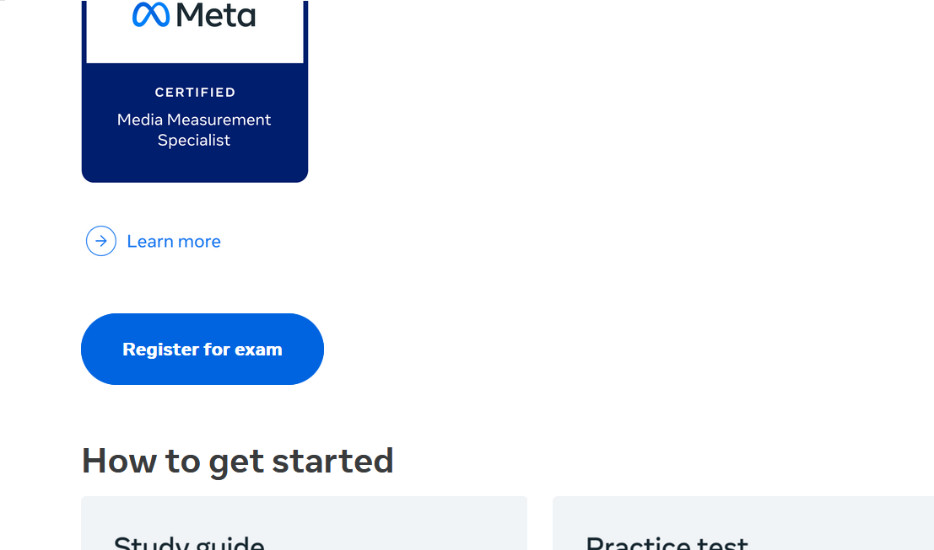

Now if you click on Register for exams then it will ask you some basic details or any profile type and then it will give you options to schedule your exam

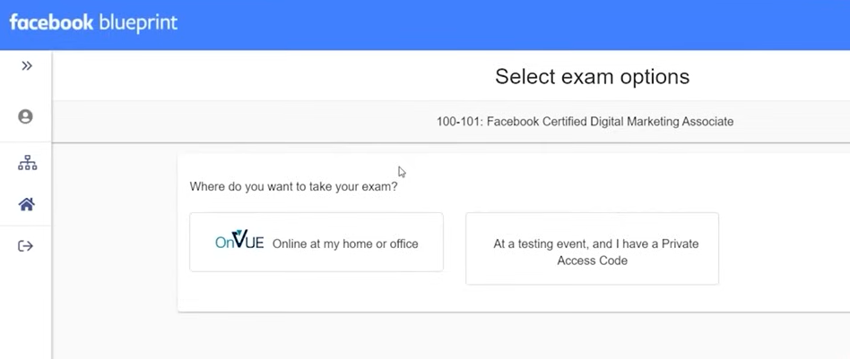

From Teacher POV

Now you can see above that you have two option that whether to gove exam in facebook centers or you can give it online

Most;y choose online and if you click on online then you will see the below

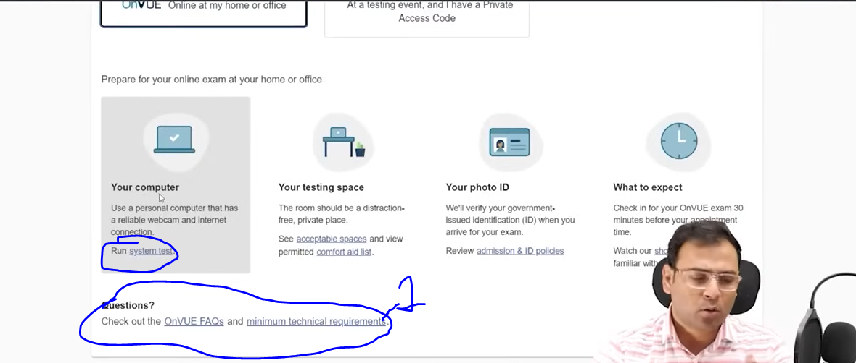

They are also govong you option that in prepearing exam what you need ot keep in mind

Itsays that you should have a computer system with proper webcam and internet connection

You can also do run system as marked above

They also monitor your space

In this exam the invigilator will see yiu through webcam that what activity you are doing and they also check In you r os no one there hether your room is empty or you have other systems

You should have a photo id

And it also saying that that check in befoire 30 minutes of your appointment time

So you need to tke thiese things seriously and prepare for it

There are some technical requirement also by click on gon marked 1 above

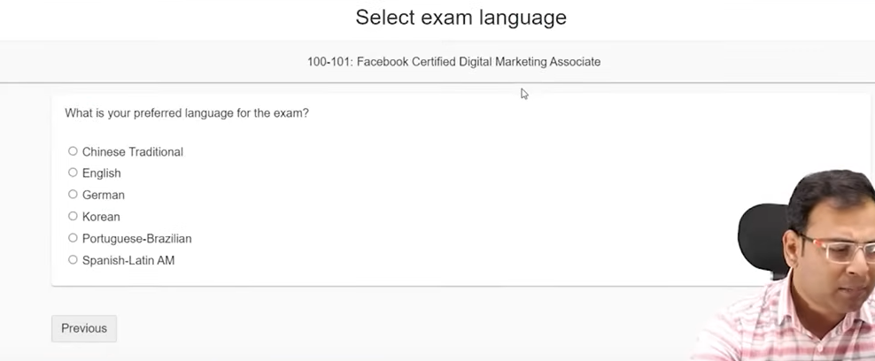

Now they will ask you language you prefer to give exam

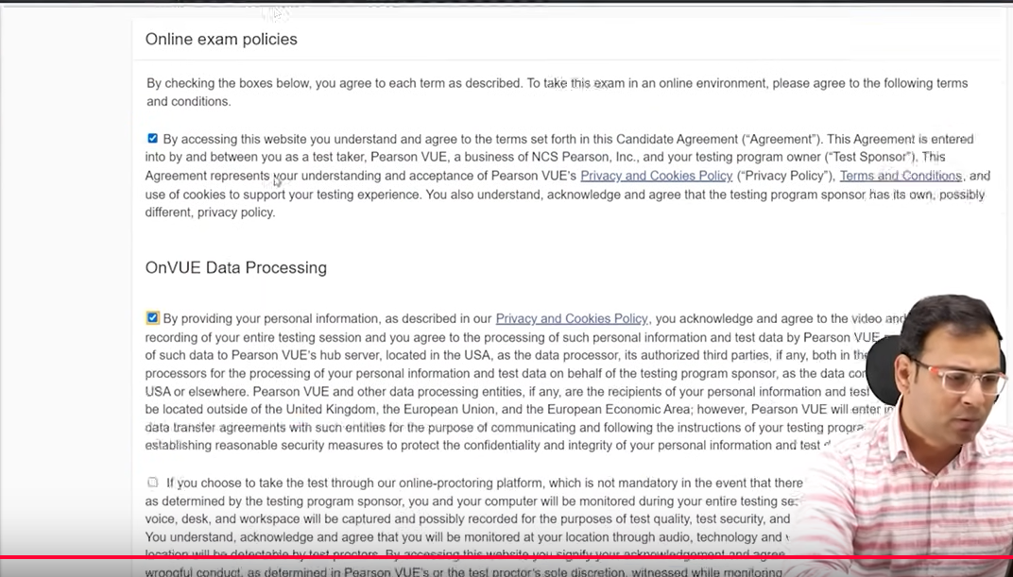

Now you are given terms and condition related to data processing and exam

Click on agree bottom

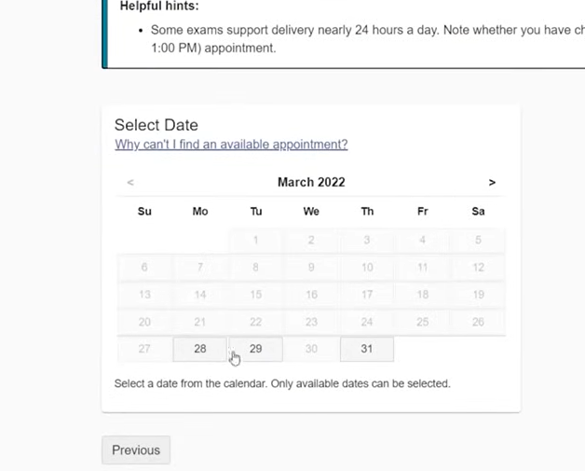

NOw it will give you option to select the date

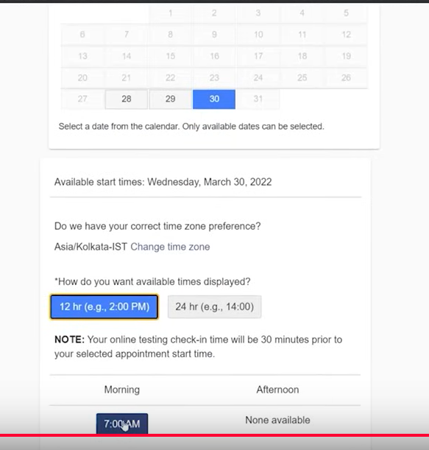

After selecting date then you can choose time now it will ask you mayment rekated detail as shown below

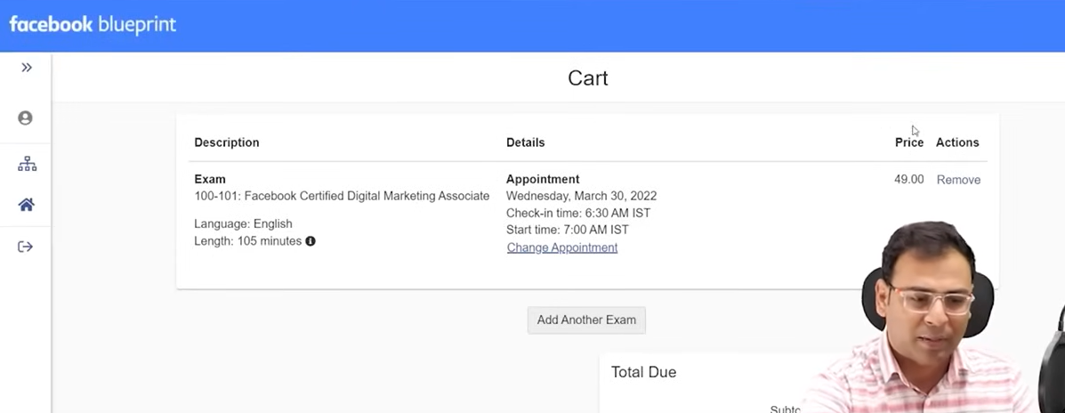

NOw you can see the price is given below 49 dollars

Tax wil aslo be added Now checkout and by following rules an regulation of the exam you can give your exam

So by this you will get the certificate if you cannot clear it then you have to pay again and give the result

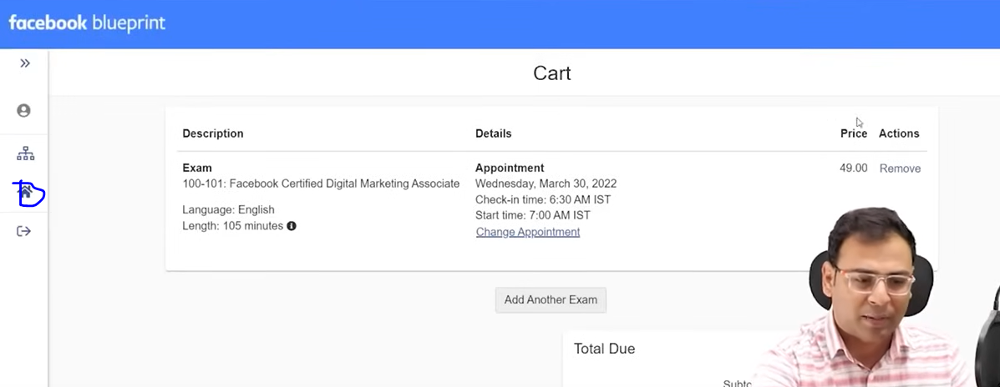

Now click on marked above to exit from here

So we come back to home

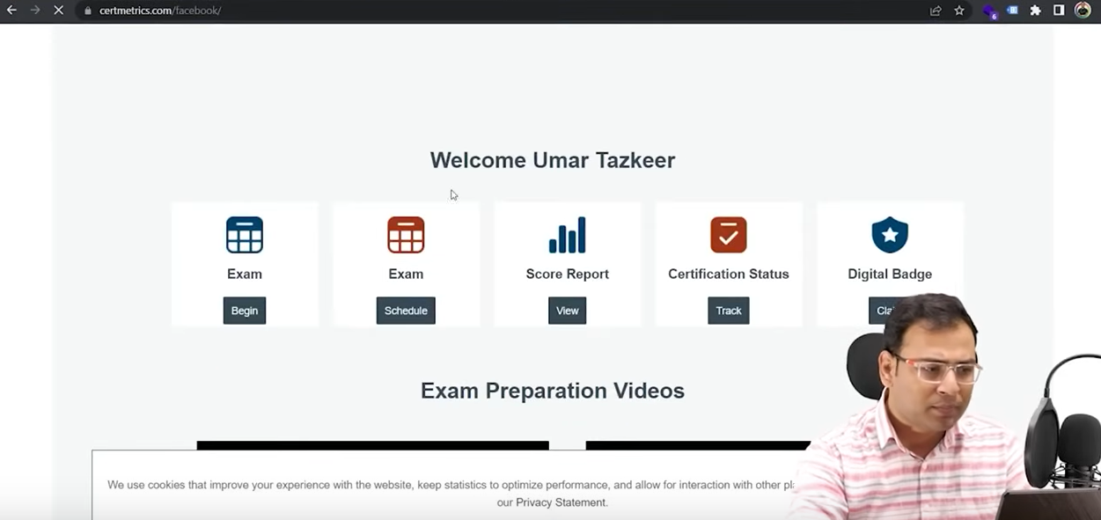

As we have already logged in

You will see yor dashboard as shown above and you

What exam are scheduled and you can see score report and wat is the status of the certification



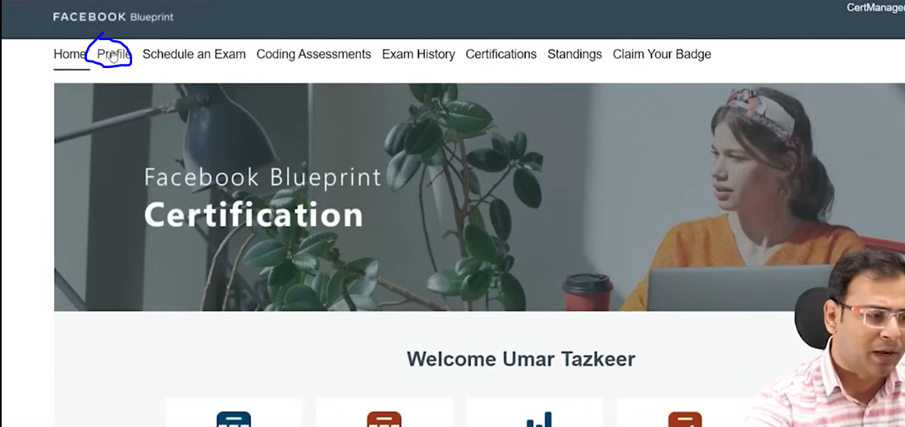

Now you can see your profile by clicking on the marked above

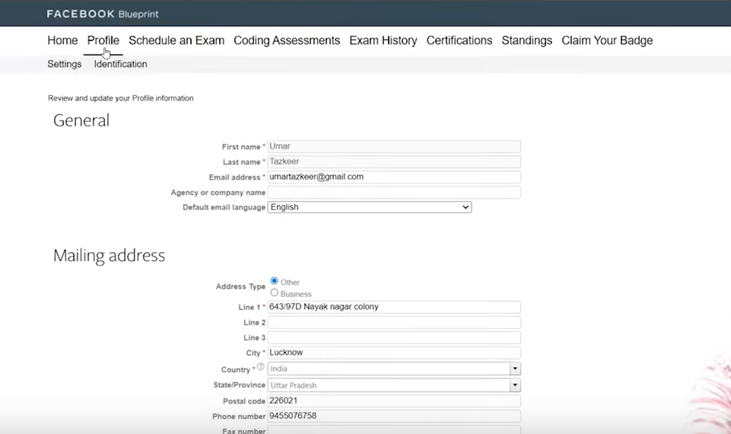

And by clicking on schedule an exam menu you can schedule your exam

Now if we come back to certification

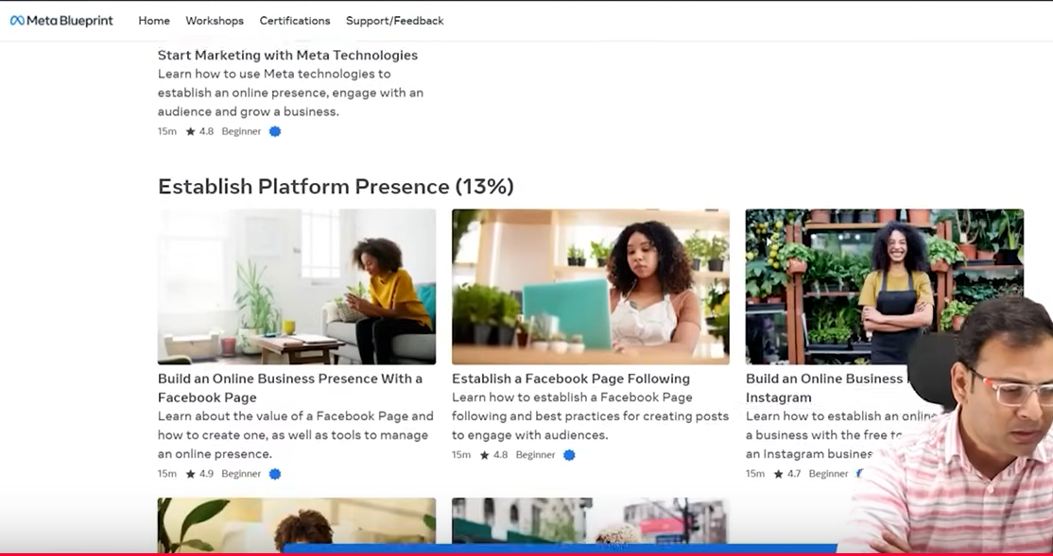

Now below the detail of the certification you will see the tutorials related to it now if yyou click on the block on second box

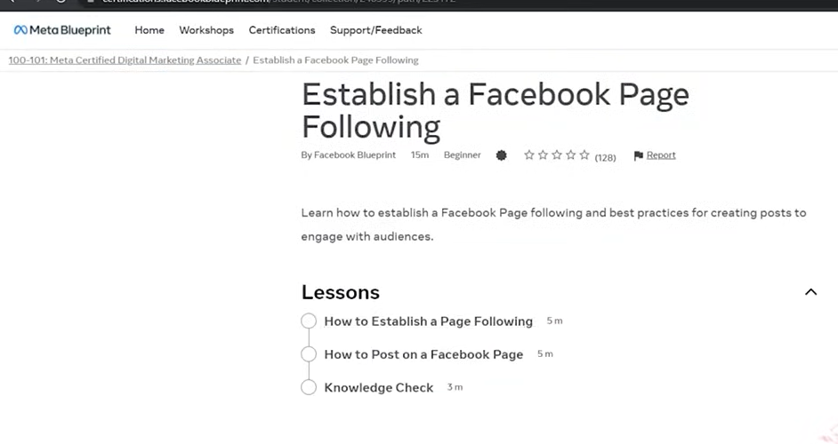

Then you canse the material here but the certification are not free



You have workshop menu, Support/Feedback in menubar

They have created proper learning system from which you can learn many things and acquire certification

Every certificate has there cost onteh range of 50 to 150 dollars

NOw we see the similar steps for Media Buying Professionals

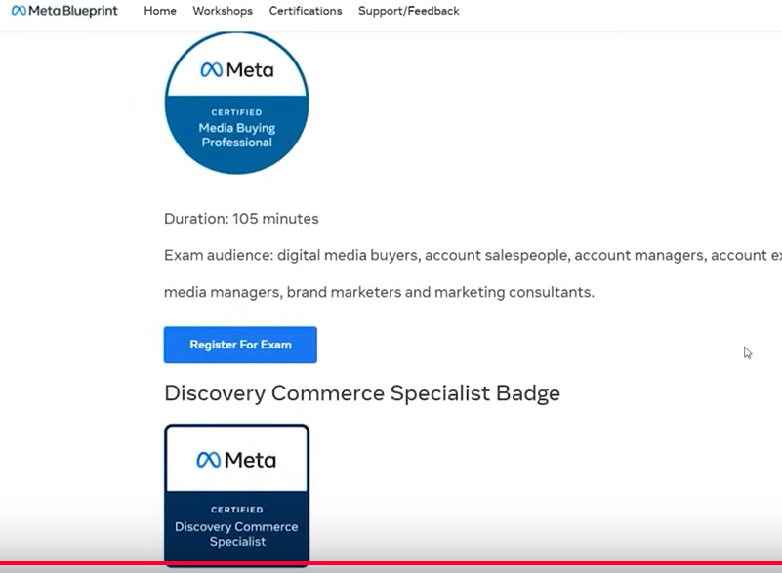

Now we cloick on Register For Exam

It is of 105 minutes exam

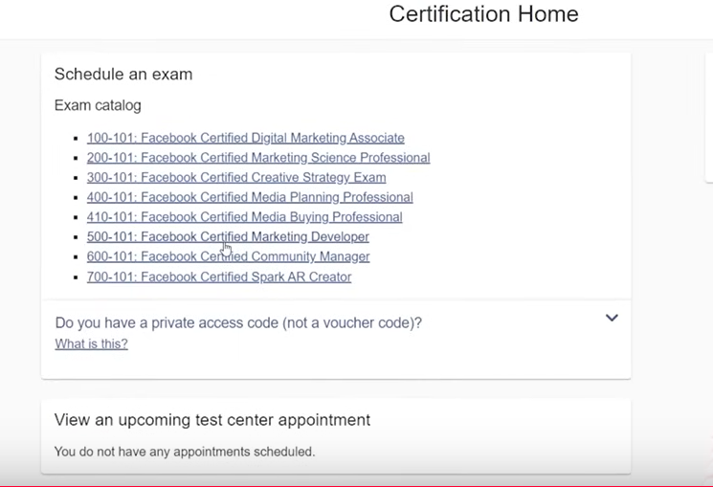

Now you can see the exam catalog

We choose rtified Marketing developer

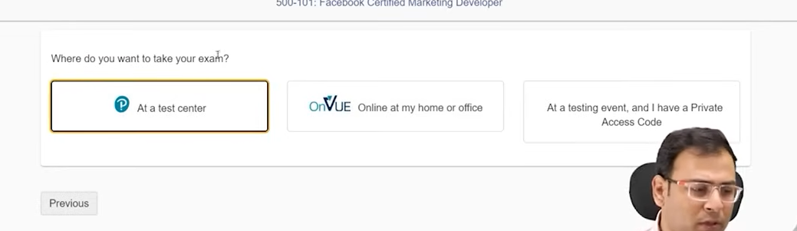

Now it will givw you option where you want to give the exam

Some countries or places has the facility to condiuct eam some have not

Most people don’t talk about it mostly hteu talk about oogle certification

Like Google Hubspot and its learning material is also good

But main thing is money since they are free pepoentry to achieve there certification

According ot teacher these certification does not have that much value if you are going for a job

Main thing is practical knowledge if you don’t have it then thesecertification wil not give you anything yes it is an added advantage but the base thing is knowledge or practical knowledge, case study or documentation

**Lesson 93:-**

In this lesson we will learn about **Create Instagram Story Polls Ads**

We are going to talk about if you want to use polls in our instagram stories then how you can use it

Sometimes we want that we have engagement in our ads and if we want that engagement is in terms of poll like we run an ad and we want that we ask from audience or prospect some question and they answer these question in terms of polls and we can see what response they have given

So basically we are saying that inside our instagram story ads if we add polls as ad then how to do it

Lets say we create Traffic Campaign we don’t have to bring some changes in camping level

Now in ad set level if you go to Manual Placement

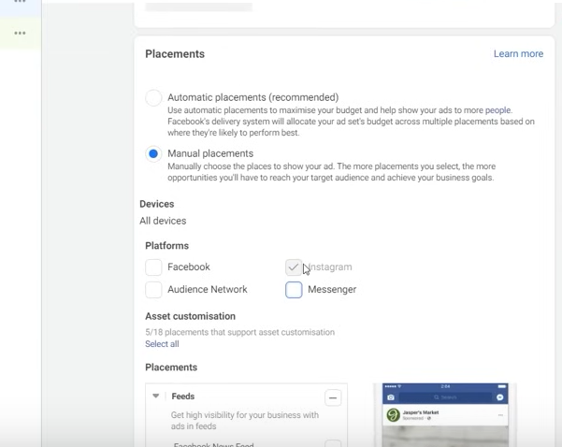

Then off all things and only choose Instagram

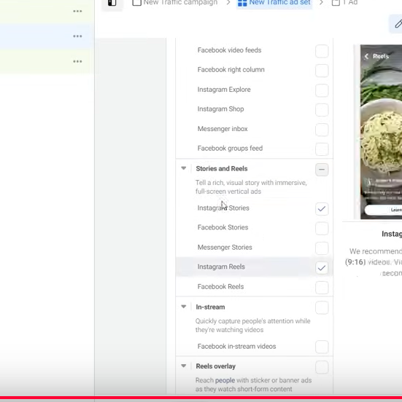

Snd in instagram you have to choose Stories an reel and inside just choose Instagram stories and unselect reels

Now if you go to Ad level

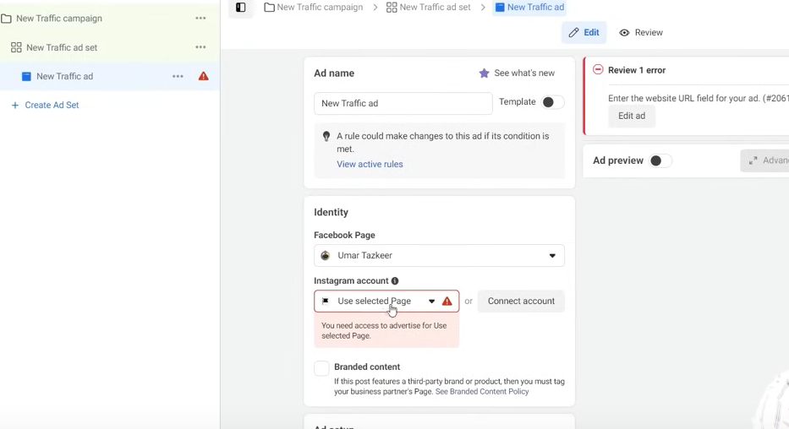

And now choose your instgram account

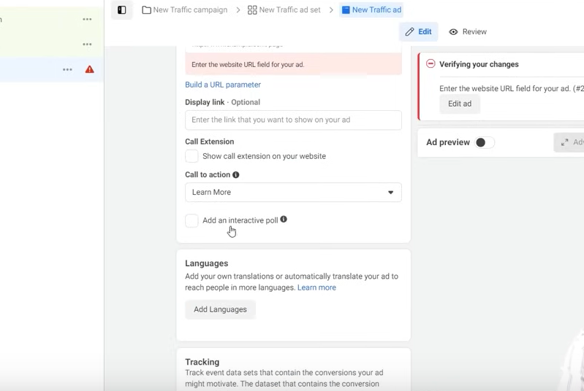

And now below you will see the option for adding an interactive pol as where our pointer is in the picture

So it mean the creative in the form of your stories if you will upload it then along with that

You can add poll also there

**Phase 119**

NOw if you go back and choose Instagram Reels then

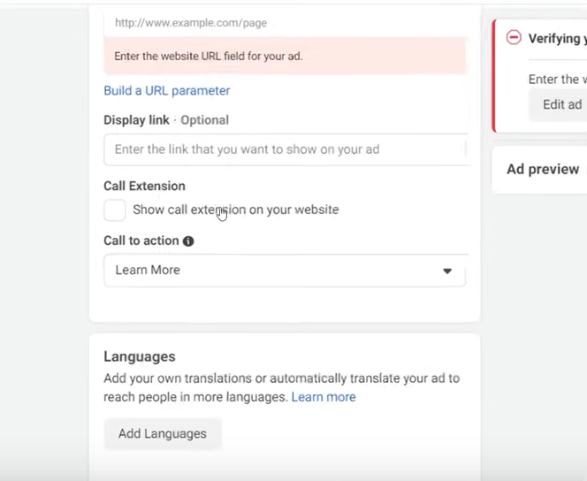

You can see the interaction poll option is not visible now

So this means if you choose stories then only you can see instagram polls

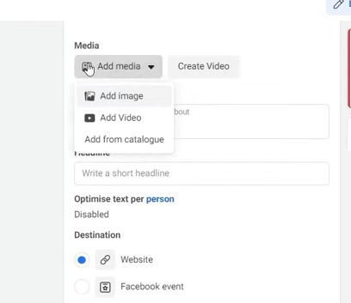

Now suppose we choose a media in your creative

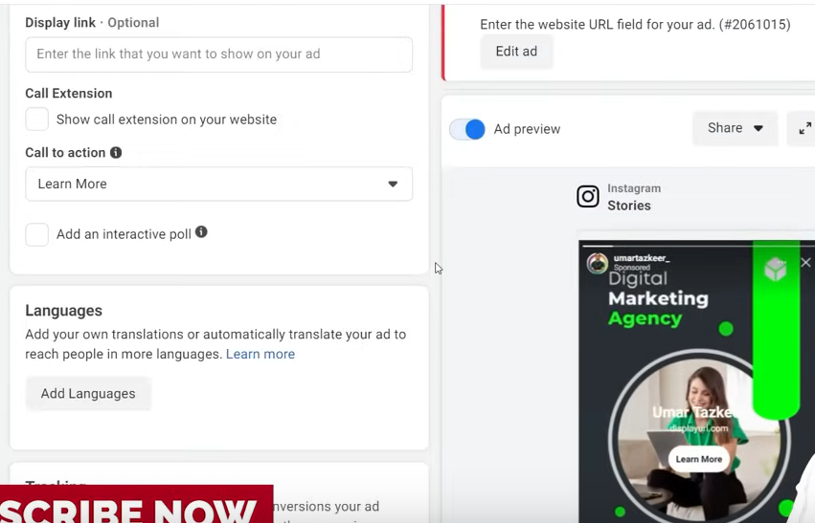

Now you can see your media in your preview

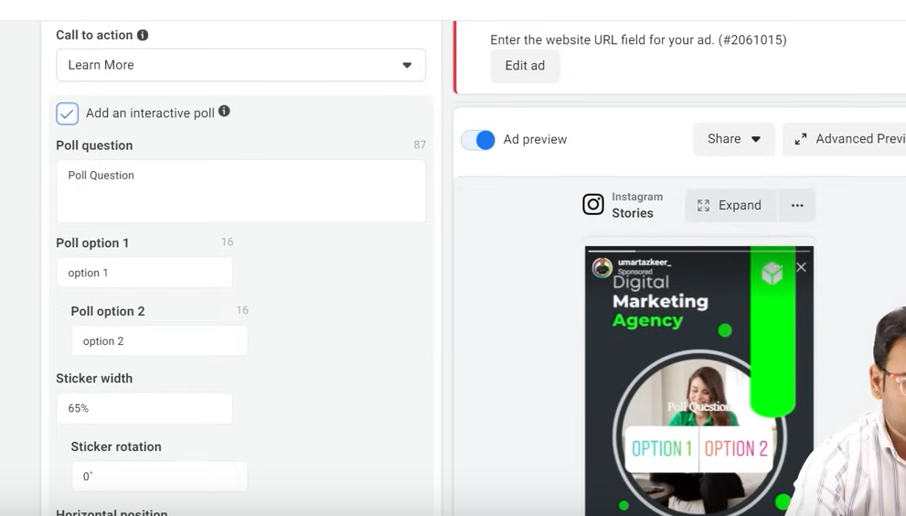

Now as you click on the Add an interactive poll checkbox then you will se form below it which will be expanded

You can see here polls question and the options or it in the form 2 an other configuration

Lets say we are promoting a digital marketing Agency and here we can ener question or we can add interactive type of element so that people can interact with it

So element is in the fomr of poll

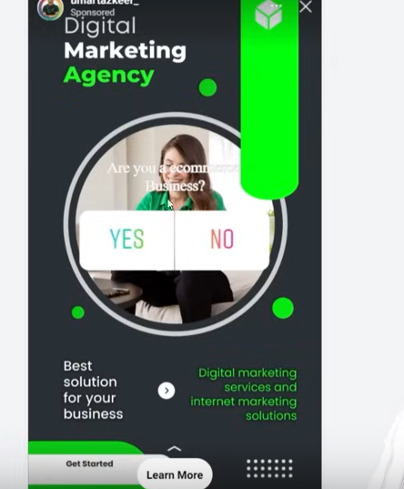

Now in preview you can see the question as well the option we give

Now ther are things which we need to keep in mind

You have to set its positioning carefully

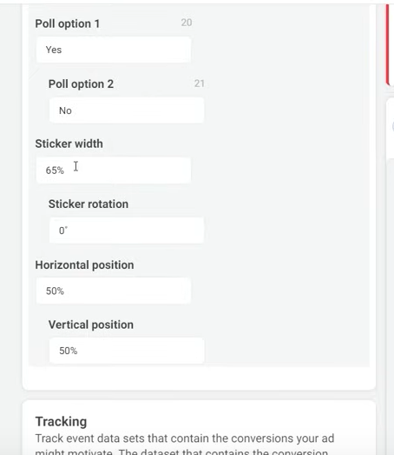

Like we can tune Stiker width

You can also sticker rotation

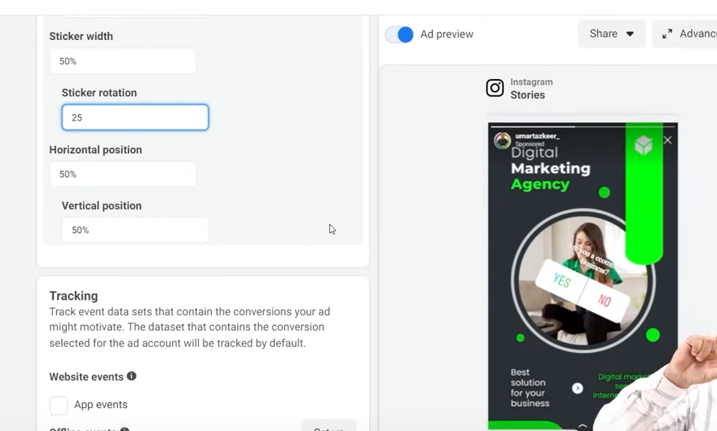

Negative means clockwise

You cannot set the steaker or anything by drag and drop

And another problem is that the poll text question is always white

So things to beware of is that the background should be dark so that white color look good there because both white will not look good there

Now in horizontal poition you can set it horizontically by oercentage and in vertically you can set the vertical position by percentage some percentage is onvalid if the sticker go outside of viewable area

Remaining things are same like you see in normal ads the way you use htem the way you select the audience and like you can also run multiple creative all other things you have to do the same

Now another question there

We run this ad and people interact with it give response to it wher we will see those responses

So when you run yours ads go to ad section later as shown below

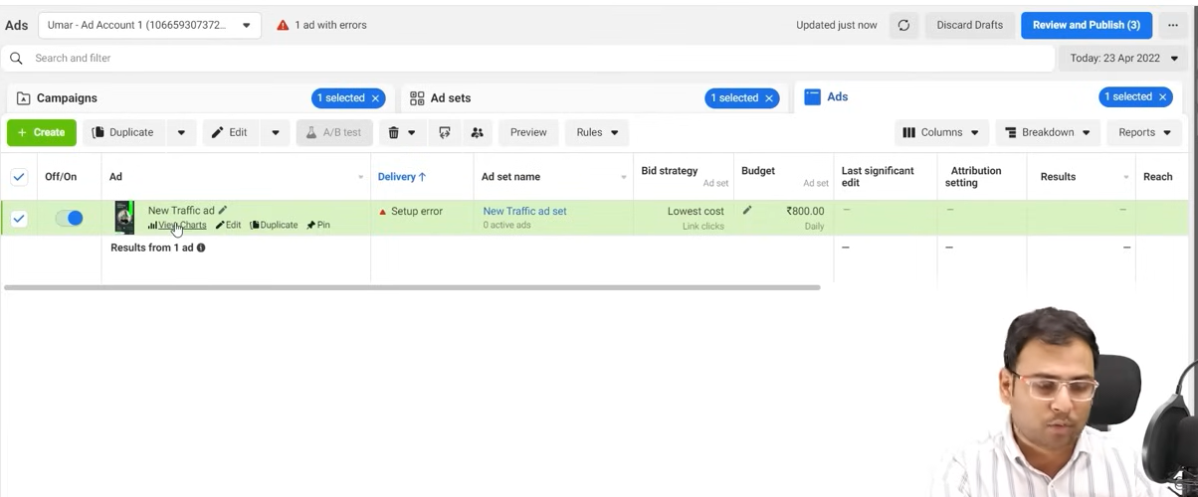

Nowin the ads which cantaind the stories go to View charts where our pointer is in the image

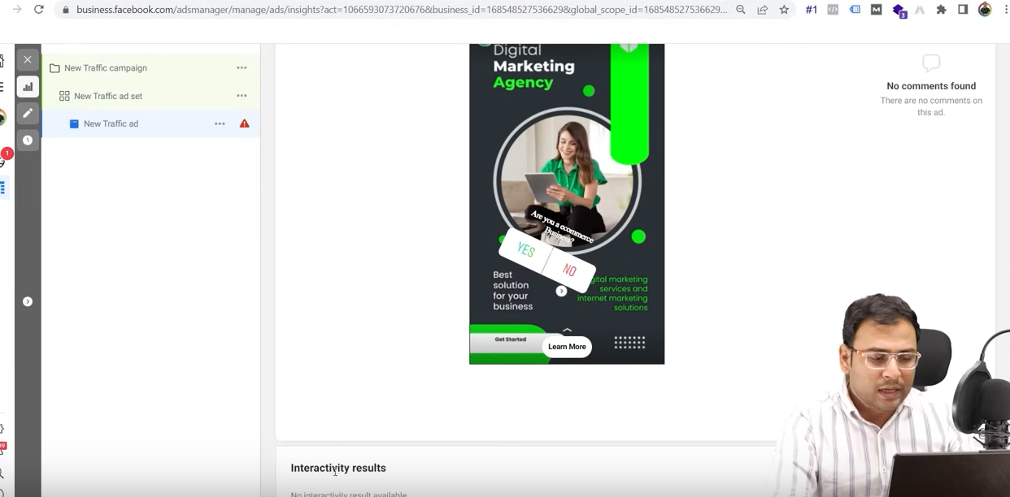

Now a new page will oprn now go to Interactive results as shown in the bottom of the screen

Now below it you will see in which poll what are the responses measn you will see the poll result here

Many times it happens that where we run some ads or other stories ads where we want that our prospect or potential customer or audience we can capture there interaction or responses

If you wna to capture those responses as a poll then this is the best option but the things to give attention is that when you place you placement there you make sure that you only select Instagram Stories If you chose other option with it then this interactive polls option will disappear you will not get it and you get thise option in ad level of campaign

**The End**